**Matrix Models for Wildlife  
Conservation and Management**

**Lab Exercises**

**2-6 May 2022**

**Univ. of Aberdeen**

**Aberdeen, Scotland, UK**

**Jean-Dominique LEBRETON, Jim HINES,**

**Xavier LAMBIN, Chris SUTHERLAND, Madan OLI**

**University of Aberdeen**

**The Sir Duncan Rice Library, Bedford Road, Aberdeen**

Contents

SOFTWARE 4

APPROACH TO CONDUCTING THE EXERCISES 4

EXCERCISES 5

Exercise 1: Exponential Population Growth Model 5

Exercise 2: Logistic Population Growth Model 9

Exercise 3: Life Table Analysis and Lotka-Euler Equation 12

Exercise 4: The Barn Swallow Matrix Model 15

Exercise 5: Sampling variance of growth rate, swallow model 17

Exercise 6: Perturbation Analysis of the White Stork Model 19

Exercise 7: Two-Site Matrix Models for Black-Headed Gulls 21

Exercise 8: Chamois in Random Environments 23

Exercise 9: The Ricker Model of Density Dependence 25

Exercise 10: Demographic Stochasticity in the House Sparrow 26

Exercise 11: Plight of the Polar Bear 28

Exercise 12: A simple Integrated Population Model 32

Exercise 13a: Exploitation in a Matrix Model with Two Sexes 33

Exercise 13b: Management of Overabundant Cormorant (on your own) 34

Exercise 14: Whooping Crane PVA 36

Exercise 15: Polar Bear PVA 40

SOLUTION TO EXERCISES 43

Solutions to Exercise 1: The exponential population growth model 43

Solutions to Exercise 2: The logistic population growth model 47

Solutions to Exercise 3: Life table analysis 51

Solutions to Exercise 4: The barn swallow matrix model 51

Solutions to Exercise 5: Sampling variance of growth rate 56

Solutions to Exercise 6: Perturbation analysis of the white stork model 58

Solutions to Exercise 7: Two-site matrix models for black-headed gulls 62

Solutions to Exercise 8: Chamois in random environments 65

Solutions to Exercise 9: The Ricker model of density dependence 67

Solutions to Exercise 10: Demographic stochasticity in the house sparrow 70

Solutions to Exercise 11: The plight of the polar bear 73

Solutions to Exercise 12: A simple integrated population model 78

Solutions to Exercise 13a: Exploitation in a matrix model with two sexes 80

Solution to Exercise 13b: Management of Overabundant Cormorant 82

Solution to Exercise 14: Whooping crane PVA 84

Solution to Exercise 15: Polar bear PVA 88

REFERENCES 99

# SOFTWARE

We have designed the exercises using R

Please download the current version of R software (<http://cran.r-project.org/index.html>) and R packages *popbio* and *nls2* to your laptop computer before coming to the matrix modelling workshop.

**Disclaimer**: Note that we WILL NOT be teaching attendees how to use R, as that is a topic for a workshop in and of itself.

# APPROACH TO CONDUCTING THE EXERCISES

We note that this is a workshop, and our primary goal is to help you learn about the basics of modelling structured populations for conservation and management purposes. Additionally, we want to help you learn how to construct and analyse an array of useful matrix population models with computer software. There will not be an exam testing your memorization capabilities or anything like that.

Below are the exercises for this workshop and we are also providing you with (possible) solutions to the exercises in R to help you address difficulties and questions as the instructors frantically try to address questions in person during the workshop. However, we highly encourage you to conduct the exercises without referring to these solutions until absolutely needed to make progress. There are many potential solutions to some questions, each of which may be equally correct. You will learn more, and get more out of the workshop, if you try to conduct the exercises on your own; only checking the solutions to make sure you are heading in a good direction. R users: after the first couple of exercises, we encourage you to try writing your own code to address the exercise problems before consulting the solutions.

# EXCERCISES

## Exercise 1: Exponential Population Growth Model

The exponential population growth model – the simplest of all population growth models - describes the dynamics of populations in unlimited and homogeneous environments. Because most environments cannot provide limitless amounts of resources, one might think that there should be few examples of population growth. True, yet not so true because there are many examples of exponential growth in nature. In fact, most populations grow exponentially during some part of their histories. Exponential growth can be easily observed initially in most laboratory cultures. Most invasive species introduced into a novel, but suitable environment almost invariably grow exponentially. One can think of many examples – Burmese pythons in the Everglades, Kudzu vine in the southeastern US, Himalayan Tahr in New Zealand, grass carps in the Mississippi river and its tributaries, European hare in Australia, and the list goes on.

Exponential population growth is described by the differential equation



or the equation in integral form:



where *Nt* is the projected population size at time *t, N0* is the initial (or starting) population size, *r* is the continuous time *per capita* population growth rate or *Malthusian parameter*, *t* is time and *e* is the base of the natural logarithm (a constant, *e* = 2.718…). So, given *N0* and *r*, we should be able project population size for any future time, *t*. R, a freely available software, makes such calculations quite easy, so let’s started with example with made-up parameter values, and then move on to the analysis of the whooping crane population dynamics.

**Exercises**

1. **Exploration.** Open the file “Ex1_Exponential_growth.R” in R Studio or a text editor (e.g., Notepad++, TINN-R). Study Part 1 of the code, which includes example calculations for hypothetical parameter values: *N*0 = 100; *tmax* = 50 years, and *r* = 0.05. Plot the population trajectories and calculate the time that would take for this population to double and triple in size.
2. Assume now that your study population is declining at the rate of r= -0.02. Project the population trajectory, assuming *N*0 = 100 and *tmax* = 50. How long would it take for this population to decline to half and one-third of the starting population size?
3. Using the function *project.exp*, project the population size assuming *N*0 = 50 and *tmax* = 100 for the following values of *r* = -0.06,-0.05, -0.01, 0.005, 0.0, and 0.01. Plot the results in real and log scales.

1. **Whooping crane population dynamics.** Part II of the code deals with the analysis of time series of abundance data for the endangered whooping crane (*Grus americana*) population – the ONLY remaining natural migratory flock (Aransas/Wood Buffalo Flock) of whooping cranes (<https://www.pc.gc.ca/en/pn-np/nt/woodbuffalo/decouvrir-discover/science_nature/Cranes_Grue>; <https://www.natureconservancy.ca/en/what-we-do/resource-centre/featured-species/birds/whooping-crane.html>). The population was threatened by imminent demise – there were only 21 cranes remaining in 1940. The population has responded positively to conservation measures and is doing much better now, with an estimated 800 cranes as of 2018.

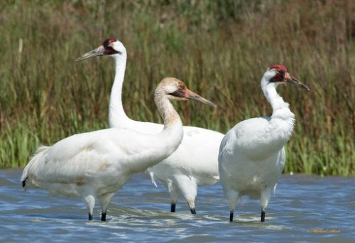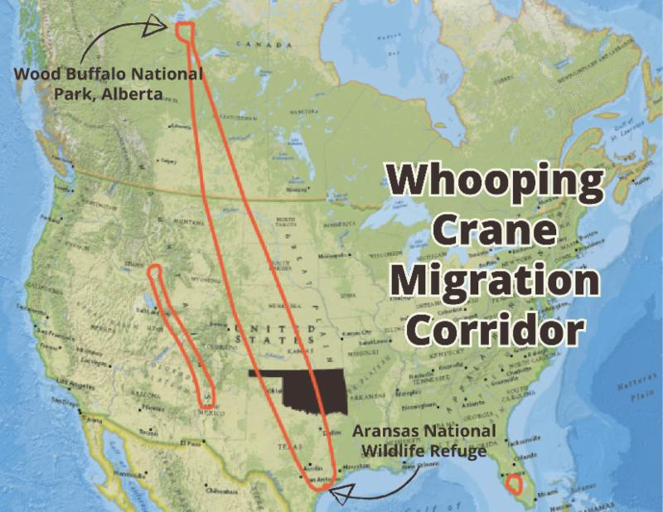

**Whooping cranes Migration route**

Wildlife managers surveyed the crane population every decade until 1989, and annually thereafter. Looking at the time series of population estimates, it appears that the population grew approximately exponentially so fitting exponential population growth model to these data seems appropriate. However, we will limit our analysis to annual census data (i.e., collected in 1990 and later).

An important feature of these data, as we will see later, is that the population counts are supposed to be exact; i.e. with no sampling variability.

There are many methods for estimating long-term *per capita* population growth using time series of abundance data. Intuitively, the ratio of population size at successive time steps should provide the one-step estimate of *realized* finitepopulation growth, λ. And we know that λ and *r* are related to each other: λ = e*r*, and *r* = *ln*(λ). Formally,

So, all we have to do to estimate time specific finite growth rate is to take the ratio of population size at times *t* + 1 and *t* to get one time-step estimate of λt, and then take its natural log, which is a time-specific estimate of per capita growth rate *rt*! This can be easily implemented in R (see the code file). One can then calculate mean and variances; the mean of λ*t* and *rt* quantify long term finite and continuous time population growth rates, respectively, and their variances generally quantify environmental stochasticity (which will be discussed in detail later).

This is where it is important to assume that population counts are not affected by some sampling uncertainty. This assumption insures that successive estimates of $λ_{t+1}$ and $λ_{t}$ are independent, a key issue for making their empirical variance estimate valid. This variance (or equivalently, that of $r_{t}=ln(λ_{t})$) can then be considered as entirely linked to population processes.

1. Calculate the annual finite (λ) and continuous (*r*) population growth rates. When did the population grew at the highest rate, and when did it grow at the lowest rate? Can you speculate about why those years were the best and the worst years for the whooping crane population?
2. Calculate the mean and variance (or SD) of the finite and continuous population growth rates. What do the mean and variance of population growth rate tell you about whooping crane population dynamics? What do you think would happen if the SD of the population growth rate was twice as high? What would be the conservation implications?
3. Based on the mean *per capita* population growth rate, calculate the doubling and tripling times. Do you think this population will continue to increase at the same rate forever? Why or why not?
4. Plot the observed and model-predicted whooping crane abundance data, and briefly comment on the fit of the exponential population growth model to these data.

## Exercise 2: Logistic Population Growth Model

The exponential population growth model we have discussed so far describes population dynamics in an unlimited and homogeneous environment, where birth and death rates (and thus, population growth rate) are constant. In other words, the exponential model describes unbounded growth and decline of a population, both of which are generally unlikely under natural conditions. We know resources are not unlimited in most natural environments – as the population size increases, *per capita* availability of resources will undoubtedly decrease. At some point, resource limitation will kick-in, and the population will stop growing. This kind of thinking has led to the idea of density-dependence, and the logistic population growth model, which describes density-dependent population growth. The continuous time differential equation model is:



With solution:



where *Nt* is the projected population size at time *t*, *r* (more precisely, *r*max) is the continuous time per capita population growth rate when population size is very small, and *K* is the carrying capacity or equilibrium population size.

**Exercises**

1. **Exploration.** Open the file “Ex2_Logistic_growth.R” in R Studio or a text editor (e.g., Notepad++, TINN-R). Study Part 1 of the code, which includes example calculations for hypothetical values for *r*, *K*, *N*0, and time vector *t* (0 to *tmax*). The function *c.logist()* is a direct translation of the logistic population growth model. It takes values for *r*, *K*, *N*0, and *t* as input arguments and projects the population size. Explore the code, change the values of input arguments and study how logistic growth model behaves in continuous time.

Change values of *r*, *K* and both *r* and *K*, and study the model behavior.

* 1. What would be the effect of increasing *K* and *r* one at a time, and both *K* and *r* simultaneously on model behavior?
  2. What if you increased *r* but decreased *K*, and vice versa?

1. **Modeling China’s human population growth**. Part II of the code analyzes the dynamics of China’s human population.

China is the most populous country in the world; population size estimated for 2020 is 1.44 billion, which is about 18.5% of the total world population. During the 1960’s and 1970’s, China’s population was growing rapidly at the rate of 2-4% per year. To curb the population growth, Chinese government implemented the “one child policy” in 1980. Not surprisingly, the one child policy was very effective in curbing population growth rate, which currently stands at about 0.3% per year. The one child policy ended in 2016. In this exercise, we will analyze the dynamics of China’s human population for the period 1961-2015. Study the code used to estimate model parameters (*r*, and *K*), fit the model and plot the results.

1. What are the estimated values for *rmax*, SD(*rmax*) and *K*? How would you interpret these results?
2. If the population had gone on increasing at the rate of *rmax* and, how long would it take the population to double and triple in size? Why do you suppose China’s population did not continue increase at the same rate?
3. Based on the relevant plots (e.g., observed vs. predicted population size, plot of *r* vs. *N*), how good is the model fit? Do you think China’s human population followed a logistic growth during the study period?
4. Project and plot the population size for 100 years. What is the model-predicted population size in the year 2021 and 2100? How likely is it that this prediction will hold to a reasonable degree?

**Discrete Time Logistic Growth Model And Parameter Estimation Using Non-Linear Regression (Fyi Only)**

The logistic population growth model we have discussed so far is the continuous time model. We can write the logistic growth model in discrete time as follows:



where *rd* = λ-1 is called the “discrete growth factor”. These types of equations are called “difference equations” (as opposed to differential equation in continuous time). This seemingly simple equation can exhibit complex dynamical behaviors. For small values of *rd*, this model behaves just like the continuous time version of the logistic growth model. But the model behavior could be very different for large values of *rd*. This (and other variations of discrete time logistic population growth models) exhibit a variety of behaviors, ranging from standard logistic growth for small values of *rd* to cyclic and chaotic behaviors for larger values of *rd*. We will revisit

Part IIIA of the code shows how to fit the discrete time version of the logistic growth model, and Part IIIB shows how to estimate model parameters using non-linear regression analysis. Explore this on your own if interested. We will revisit some of these ideas later in the workshop.

## Exercise 3: Life Table Analysis and Lotka-Euler Equation

Both exponential and logistic growth models ignore age-specific differences in survival and reproduction and treat all individuals in a population to be identical. Because they ignore age or stage structure, they are often called “unstructured” models. But we know that there are age-specific differences in birth and death rates. For example, very young or very old individuals typically do not reproduce and also experience higher mortality rate compared to prime-aged individuals. It is necessary to account for age or stage specific differences in survival and reproductive rates when possible. Life table analysis was the first continuous time modeling approach that considers age-specific differences in survival and reproductive rates. Note that matrix population models (the focus of this workshop) are the most appropriate framework for modeling age- or stage structured populations. We introduce life table analysis simply because matrix models evolved from life table analysis.

For this exercise, we used life data for female yellow-bellied marmots (*Marmota flaviventris*) as an example. Yellow-bellied marmots are fairly large (~5kg) ground-dwelling sciurid rodents found in western United States and south-western Canada. Based on a long-term study conducted by Ken Armitage, Schwartz et al. (1998) compiled life tables for both male and female marmots – we will use data for females in this exercise.

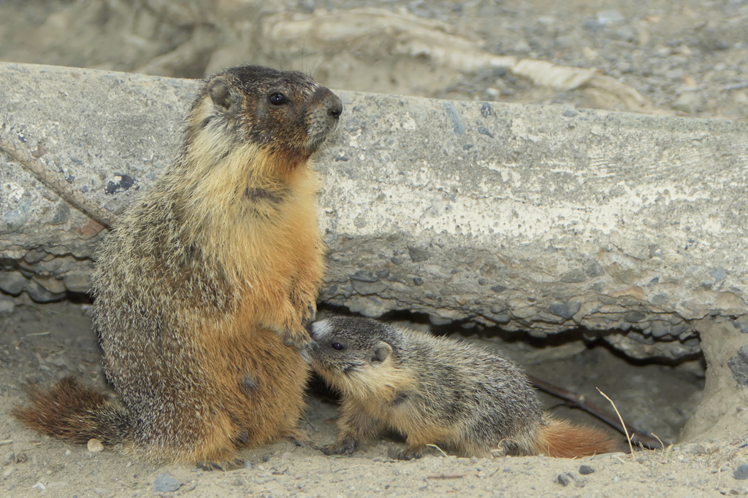

So, what is a **life table**? In a nutshell, a life table is an ‘age-specific summary of survival and reproduction’ for a population. Typically, ecological life tables present data on survivorship (*lx*) and fecundity (*mx*) for each age, *x* (or data that can be used to calculate survivorship *lx* and fecundity *mx*). Life table data are valuable because they permit calculation of many quantities that are useful in population ecology, life history and evolutionary studies:

**Net reproductive rate (*R0*):** The net reproductive rate is the average (expected) number of daughters produced by a female over her entire lifetime. This is a measure of per generation population growth, and can be calculated as:

**

**Generation time (*G*):** The generation time can be defined as the mean age of the mothers of a newborn ‘cohort’ (the average age of a mother when she has her first litter of infants), or the time required for the population to grow by a factor of *R0.* Calculation is straightforward:



***Per capita* population growth rate (*r*):** We can calculate approximate value of *r* based on the net reproductive rate, *R0,* and the generation time, *G*, that we just calculated:

**

In R, we use the log() function, which calculates the natural log (note that in some computer programs such as Excel, log() returns log10 and ln() returns natural log).

The method we used above gives us a reasonable approximation of *r*, but we can also calculate the exact value using the Lotka-Euler equation.

.

Here, α and ω refer to age of first reproduction and age of last reproduction, respectively; *lx* is the age-specific survivorship and *mx* is age-specific fecundity rate. This seemingly simple formula is the single most important equation in population ecology and life history theory because it explicitly links age-specific survival and reproductive rates to the population growth rate (which is also a measure of fitness). This forms the foundation of demographic theory. Virtually all structured population models (including matrix models, which we will consider next) are based on the Lotka-Euler equation.

The discrete time version of the Lotka-Euler equation is:



This equation can be rearranged to make this a zero-finding problem (computers are very good at finding zero):



which is identical to the preceding equation, just rearranged. The value of *r* that makes this equality true is the exact value of per capita population growth rate, *r*. Note that *r* calculated using the Lotka-Euler equation is related to finite population growth rate λ as: *r* = ln(λ), and λ = e*r*. Both λ and *r* thus calculated are measures of asymptotic population growth rate.

Open the file Ex3_Life_table_analysis.R in R Studio (or a text editor of your choice), and study the code. The code reads the life table data, produces basic plots, calculates the net reproductive rate (*R0*), generation time (*G*), and approximate value of the continuous time population per capita population growth rate, *r*. Finally, it uses the Lotka-Euler equation to calculate the exact value of per capita population growth rate.

Note that matrix models can do everything that life table analysis can do, and a whole lot more – that’s why the rest of the workshop will focus on matrix population models.

## Exercise 4: The Barn Swallow Matrix Model

This exercise closely follows the content of the first lecture and is mostly intended as a first contact with matrix models. We have prepared exercises for use in R.

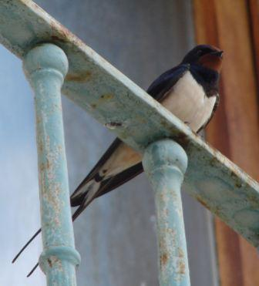Assume that the dynamics of a barn swallow *Hirundo rustica* population can be adequately represented by a model using two age classes (1st Year and After 1st Year, FY and AFY, with respective abundances denoted as N1 and N2), and the following vital parameters:

*f*1 = number of females fledged per female aged 1

*f*2 = number of females fledged per female aged 2 or more

*s*0 = survival from fledging until the following spring

*s*1 = annual probability of survival from age 1 to 2

*s*2 = annual probability of survival for older birds

The estimated values of the demographic parameters are: *f*1 = 1.5 and *f*2 = 3.0 (assuming a balanced sex ratio at fledging time), *s*0 = 0.2, *s*1 = 0.50, and *s*2 = 0.65.

**Exercise**

1. Draw the barn swallow life cycle, making fledglings appear explicitly in your diagram.
2. Write the corresponding matrices in the pre-birth-pulse and post- birth-pulse models.
3. Open the file “Ex_4_Swallow.r” in a text editor for R (e.g., Notepad++, TINN-R, R Studio). For the moment, we will not use R packages for population dynamics, but will instead use raw code to gain a thorough understanding of age-structured population dynamics. Later, we will introduce R packages that you might find useful. Inspect the first piece of code to see if you can interpret what it does; then run the code and inspect the output to see if you understand the code correctly. What happens to population growth rate over time?
4. The next piece of code allows you to loop through two different sets of initial values: n1 = 10, n2 = 0; then n1 = 0, n2 = 10. The graph code provides comparisons of the age-specific abundances, total abundances, and population growth rates for the different initial conditions. What happens to the population growth rates and total abundances over time? You can change the time span of projection by changing the “tspan” variable, and you can also view the numerical output by simply typing the name of the variable you want to inspect in R.
5. Now see if you can develop a graph that plots the abundance of one age class against the other (n1, n2) for each of the initial conditions. This is called a “phase plane”, and is one way to view convergence of the population’s age structure to the stable age structure.
6. Now adjust the code to examine the population dynamics for the post-birth-pulse model, and compare to dynamics of the pre-birth-pulse model from above. You could just change a few lines of code, or you could ‘copy’, ‘paste’ and then adjust the code.

## Exercise 5: Sampling Variance of Growth rate, the Swallow Model

We start from the matrix model for swallows (exercise 1):

$$M=\left[\begin{matrix}s_{0}f_{1} & s_{0}f_{2} \\ s_{1} & s_{2}\end{matrix}\right]$$

The survival parameter estimates, $s_{0}$, $s_{1}$, and $s_{2}$, are equal to 0.2, 0.5 and 0.65, respectively, and considered as unbiased. We will consider the sampling uncertainty of these estimates and its effect on the estimated population growth rate. For the sake of simplicity, the estimates are considered as independent and normally distributed. Their sampling variation can thus be summarized by their respective standard errors $σ_{1}$, $σ_{2}$, and $σ_{3}$. The purpose of the exercise is to examine by simulation the sampling variance and distribution of the growth rate $λ$.

Four hypothetical scenarios of sampling variability are considered, as summarized in the Table below:

|  |  |  |  |
| --- | --- | --- | --- |
| Scenario | $$σ_{1}$$ | $$σ_{2}$$ | $$σ_{3}$$ |
| 1 | 0.05 | 0 | 0 |
| 2 | 0 | 0.02 | 0.02 |
| 3 | 0.05 | 0.02 | 0.02 |
| 4 | 0.02 | 0.02 | 0.02 |

As you can see in the Table, the first two scenarios consider variation in FY survival only, and AFY survival only, respectively. The last two scenarios consider simultaneous variations in all survival estimates, with heterogeneous and homogenous standard errors, respectively.

Although the values used in this exercise are artificial, this exercise exactly mimics what you could do in a real study based on estimates arising from a CMR study and accompanied by a sampling variability covariance matrix.

**Exercise**

The calculations can be done using the R-code in the file Ex_5_varlambda.r.

1. Check how a matrix filled in using simulated replicates of the parameter estimates is repeatedly obtained in a simulation loop, which is itself within a loop scanning the 4 scenarios.
2. Do you find that the way the repeats of the dominant eigenvalue of these simulated matrices are statistically treated is complex or simple?
3. Based on the results of the Lilliefors tests for normality, can we use a test on the multiplicative growth rate $λ$ or is it preferable to do so on the growth rate $r=log⁡(λ)$?
4. In which scenario can we decide the population is significantly growing?
5. Which parameter would you recommend to estimate more precisely in the field?
6. How would you modify the code if the 4 estimates were accompanied by a 4 x 4 sampling covariance matrix $Σ$, i.e; were no more independent

.

## Exercise 6: Perturbation Analysis of the White Stork Model

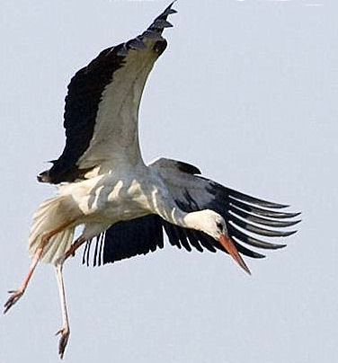From the late 1950’s to the mid-70’s, the number of white storks *Ciconia ciconia* breeding in Alsace (eastern France) rapidly declined at a rate close to 15% per year. Here we examine the impact of various demographic parameters on the dynamics of this population. Let us consider the female life cycle (sex ratio = 1:1) with 4 age classes (ages 1, 2, 3, and “4+”, respectively). The initial numbers of individuals in these age classes are assumed to be, respectively: N1 = 80, N2 = 60, N3 = 40, N4 = 100.

The available estimates of demographic parameters are:

*u* = 0.45 = proportion of breeders among 3-year-old females (100% of females older than 3 breed)

*r* = 0.818 = proportion of breeders that are successful in fledging young

*b* = 2.9 = number of fledglings produced per ‘successful pair’ per year

*s*0 = 0.482 = 1st year annual survival probability after fledging

*s*1+ = 0.75 = annual survival probability after the first year

A decline in survival was evident from analyses of ring recoveries of storks marked as chicks (1950-1970, A. Schierer’s data), but was difficult to precisely estimate because the small number of available recoveries prevented a robust time-dependent analysis. There was also evidence of a slight decline in reproductive output. Which type of change in demography is likely to have had a greater impact on stork population dynamics, changes in survival or changes in reproductive output? A perturbation analysis of a white stork matrix model can provide valuable insight into the effects of changes in demographic parameters on population dynamics. Such an analysis is useful when conservation and management is needed, or when greater rigor in monitoring and statistical estimation is needed. The purpose of this exercise is to improve our understanding of how comparable changes in survival and reproductive success affect the white stork population growth rate relative to one another.

**Exercise**

1. Open the file “Ex_6_Stork.r” in your preferred text editor. Examine the matrix model and draw the corresponding life cycle. Now run the first piece of code in R to calculate the long-term (asymptotic) population growth rate for white storks. This code uses the dominant eigenvalue of the projection matrix, parameterized with the demographic parameters provided above, to perform this calculation. To three decimals **write down the growth rate** on paper or in a spreadsheet.
2. Emulating the decline in survival that was observed (but difficult to estimate precisely), decrease survival after the first year by 20% such that *s*1+ = 0.8*0.75 = 0.6 (just make this change in the code) and re-run the first piece of code. Calculate the change in population growth rate, relative to the change in survival, by performing the following numerical calculation, where ‘abs’ refers to the absolute value of a difference:



R can also be used as a calculator (or for doing advanced algebra and calculus), so you can perform this calculation in R and store or write down the result.

1. Change after-first-year survival back to the original value of 0.75. Now repeat the same exercise for first-year survival such that the new *s*0 = 0.8*0.482 = 0.3856. Add the calculated ‘change in population growth rate, relative to the change in survival’ to that from part 2 in order to quantify the total effect of change in survival.
2. Change first-year survival back to 0.482 and repeat the same exercise for the number of fledglings produced per successful pair per year, such that *b* = 0.8*2.9 = 2.32 (a much larger change in reproductive output than was actually observed). Note that you are changing fledgling production for adults of all ages simultaneously.
3. Although the changes made to the demographic parameters in steps 2, 3, and 4 were relatively large, do you think you were approximating the ‘sensitivities’ or the ‘elasticities’ of the population growth rate to change in the underlying demographic parameters? How would you go about numerically calculating the other perturbation metric?
4. Set all demographic parameters back to their original values. Compare your calculations from steps 2 – 4 to the exact analytical calculations by running the second piece of code. Note that the reproductive values and stable age distribution are also calculated because they are components of sensitivities and elasticities.
5. Discuss the relative effects of changes in survival vs. reproductive output on population growth rate of long-lived white storks.
6. If you have time, run the second piece of code for the short-lived barn swallows from Exercise 1 in order to calculate their sensitivities and elasticities for the analogous demographic parameters, then compare to the white stork.

## Exercise 7: Two-Site Matrix Models for Black-Headed Gulls

We use here data on a black-headed gull *Chroicocephalus ridibundus* population in central France. Approximately 3000 pairs breed in a large flourishing colony on a single pond; ~3000 pairs breed in ~20 other colonies at less favourable sites. Various results indicate that many birds are forced to breed in less favourable sites by saturation of the largest colony. Matrix modelling could help us understand the functioning of this spatially structured population. For the sake of simplicity, we explore this issue using 2 sites: “Good” (G) and “Bad” (B).

The available information on demographic parameters can be summarized as follows. Resightings of birds marked as breeders in the largest colony up to 1985 were analysed by capture-recapture methods to estimate the annual adult survival probability (0.82) and the age-specific proportion of breeders (approximately 0.3, 0.5, 0.7 and 1 for ages 2, 3, 4, ≥5) for the largest colony. Breeding appears to start at an earlier age in the small unfavourable colonies, and an educated guess for the age-specific proportion of breeders in the Bad site is 0.5, 0.8, 1 and 1 for ages 2, 3, 4, and ≥5.

**Exercise**

The information above is gathered in the matrix **A** in the Ex_7_Gulls.r file. In particular, the effective juvenile migration probabilities from each location to the other, and probabilities of survival from fledging to age 1, and age 1 to 2, can be viewed in this. The model for our first scenario, which assumes a slightly asymmetric juvenile dispersal.

1. View the matrix **A** in R by simply running the first piece of code defining **A**, and then typing A in R. You will see that it is a ‘mega-matrix’ with a matrix block in the upper left for the Good location, a matrix block in the lower right for the Bad location, and migration transitions in the upper-right and lower-left blocks. Find the long-term population growth rate using the ***popbio*** package, then by calculating the dominant eigenvalue of **A** in order tocheck that the population is close to stationary.
2. Run the following lines of code that calculate the stable age-by-location distribution and the reproductive values. Comment on the reproductive values at age 1 for the two sites.
3. Conduct an elasticity analysis for the lower-level parameters in order to obtain T, the generation time, as described in the lecture.
4. Using the lower-level elasticity for adult survival , predict the change in λ that would occur if adult survival (s) were changed from 0.82 to 0.89, a change that seems plausible from data collected between 1985 and 1993.   
   This can be done using the approximations:   
   % change λ ≈ % change vital rate × elasticity, and λpredict = λoriginal × (1+ (% change in λ)/100). Implement this change in the code and find the new dominant eigenvalue of **A.** Compare your predicted λ to the actual λ and discuss how close your prediction was.
5. In piece 2 of the code, how is the ratio of breeding numbers (‘ratio’) calculated?
6. Use the provided loop to calculate the ‘ratio’ over time and graph how it changes. Explain why, like the population growth rate, the ‘ratio’ stabilizes over time.

In addition to juvenile dispersal, we will now consider adult dispersal probabilities of gb (Good to Bad) and bg (Bad to Good). Piece 3 of the code has a re-parameterization of the matrix model to include this. Initially, the adult dispersal probabilities are set to 0 such that the demography is the same as above.

1. Recent counts indicate a shift in numbers among the colonies with Ngood ≈ 5000 breeding pairs and Nbad ≈ 1200 pairs (ratio = 4.17). Can symmetrical dispersal (gb = bg > 0) induce such a change in ‘ratio’? Try dispersal probabilities of 0, 0.05, 0.1, 0.15, and 0.2 (by simply changing the parameter values at the top of the code in piece 3, and re-running the code in piece 3); remember to keep gb = bg.
2. Approximate, by successive change in bg, the level of adult dispersal from B to G (bg > 0) that can lead to a ratio = 4.17 with no adult dispersal from G to B (gb=0).
3. Interestingly, black-headed gull colonies move after reproductive failure. Comment on this trait in relation to the previous result.

## Exercise 8: Chamois in Random Environments

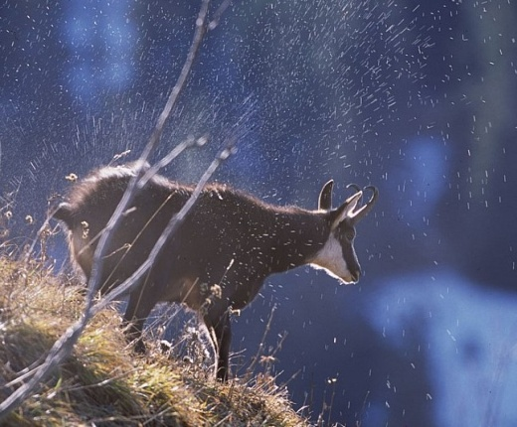Deterministic model with constant parameters:   
A Capture-Mark-Recapture study was used to estimate survival in a population of chamois (*Rupicapra rupicapra*) in the Bauges Mountain Range (French Alps). According to these analyses, four set of age classes were considered with the following annual survival probabilities:

from age 0 to 1: *s*0 = 0.660

from age 1 to age 2: *s*1 = 0.897

from age 2 to age 10: *s*2-10 = 0.962

from age 11 onwards: *s*11+ = 0.733

The proportion of breeding females at age 2 is *m2* = 0.66, and for older females it is *m* = 0.92. Each breeding female produces one young per year, with a balanced sex-ratio at birth. The initial population contains 1100 individuals.

**Exercise**

The information above is contained in the Ex_8_Chamois.r file in the section with comments entitled ‘Chamois Models’.

1. Assuming a constant, deterministic environment and using the provided code with estimates of the demographic parameters, is this population viable?
2. What happens when senescence is ignored (i.e., when survival from age 11 onwards is assumed to be the same as the previous age class)?
3. Using *s*11+ = 0.733, which demographic parameters have the strongest impact on the deterministic population growth rate?

Model with environmental stochasticity: Chamois in the Bauges experience environmental variability. In some years ‘catastrophic events’ occur, strongly reducing all survival parameters. Given the timing of these events, fecundity is not affected. Juvenile survival is reduced to ⅔ and all other survival parameters to ½ their baseline values in good conditions. On average, such catastrophes occur every 15 years. The code for this is summarized in part 2 of the Ex5Chamois.r file using a Bernoulli distribution to implement the frequency of catastrophes and catastrophic levels of survival.

1. Qualitatively, what do you think this form of environmental stochasticity will do to the chamois population, and which estimator should you use for measuring the population growth rate in a variable environment?
2. Using a pseudo-extinction threshold of 100 individuals (when demographic stochasticity can begin to have important effects on population dynamics as we will discuss later), discuss the viability and rate of population growth of the chamois population based on 500 simulations over 100 years, and then over 1000 years.

## Exercise 9: The Ricker Model of Density Dependence

To study the consequences of so-called “overcompensatory density-dependence”, that can lead to stable, cyclic, and even “chaotic” dynamics in the absence of environmental variability, we use the well-known Ricker model, based on the recurrence equation:



William Ricker developed this model in his famous studies of stock-recruitment relationships in fisheries. The equilibrium population size in the Ricker model (), when it exists, is the root of , i.e. of , which is .

**Exercise**

1. Using the first part of the code in Ex_9_Ricker.r, manually change the value of *K* (the parameter for density dependence) to explore its effect on the resulting population dynamics. Each time you change *K*, re-run the modelling code as well as that for the plot.
2. Keeping *K* fixed at 100, now explore the effects of progressively increasing values of *r*. Start from *r* = 1.7 and increase it by 0.2 each time you re-run the code. What happens when *r* >2?
3. A “bifurcation diagram” plots the asymptotic values of a state variable (which is abundance in our case) against a model parameter, such as alternative values of *r* in the Ricker model (for more info see <http://en.wikipedia.org/wiki/Bifurcation_diagram> ). As you noted in question 2, there is not a stable equilibrium for large values of *r* and the asymptotic values of abundance might bounce around cyclically or even “chaotically”; a bifurcation diagram nicely summarizes the pattern. Using the second part of the code, build a bifurcation diagram for the Ricker model and discuss it as *r* increases.
4. Part three of the code contains a metapopulation model with density dependence and spatial structure, but not stage structure (one could additionally add stage structure and environmental stochasticity; Caswell 2001). Examine the metapopulation matrix model and see if you can interpret the meaning of each transition.
5. Using the provided code, obtain a bifurcation diagram for the sink population within the metapopulation. Do the same for the source population.

## Exercise 10: Demographic Stochasticity in the House Sparrow

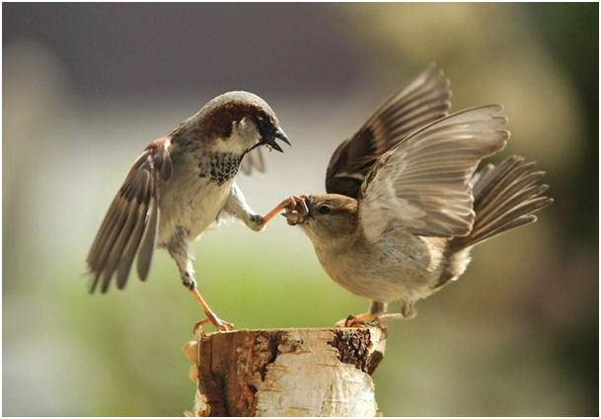Consider a short-lived species such as the house sparrow *Passer domesticus*, in which all individuals are assumed to breed at age 1.

The life cycle can be represented as follows:

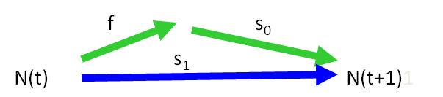

This leads to the deterministic model

$$N(t+1)= (f × s_{0} + s_{1}) N(t)$$

which can be viewed as a scalar recurrence relationship or a 1 x 1 matrix model.

One can assume that the survival probabilities are affected by density dependence according to: s0 = s0,low e –bN, and s1 = s1,low e –bN where e.g. s0,low represents the baseline survival probability from fledging to the first birthday when population density is low (we will start with s0,low = 0.2 and s1,low = 0.5). The number of young females fledged per female might logically be assumed to follow a Poisson distribution, here with a mean f = 3.

The intensity of density-dependence (b) keeps the population small enough to make it sensitive to demographic stochasticity.

**Exercise**

1. The model described above with parameter values is summarized in the file Ex_10_Sparrow.r. Examine the first piece of code to get a feel for how the scalar recurrence equation for house sparrow demography is implemented with demographic stochasticity. Run the first piece of code (including that for the plot) a few times to visualize the random impact of demographic stochasticity (coin flipping) on the dynamics of a small population.
2. Obtain a formula for the deterministic equilibrium of the house sparrow model in the absence of demographic stochasticity, but in the presence of density dependence (N*).
3. The population size conditional on non-extinction is distributed as a “Quasi-Stationary Distribution”, and the stochastic equilibrium mean is denoted as lim E(N(t)/N(t) >0), where “/” means “Conditional on”. Part two of the code has lines of code to estimate moments (e.g., the mean) of the Quasi-Stationary Distribution, extinction probabilities, and extinction times (also conditional on E[N] > 0) across 10,000 simulations. Inspect and then run part two of the code to attain estimates of each of these ‘population viability’ parameters over 100, 200, 300, and 400 years.
4. Using what you have learned above, and the third piece of code, complete rows 1-4 in the table below by manually changing the vital rate values to those specified in the table. Each time you change a vital rate, re-run the entire third piece of code (it takes time to run).

|  |  |  |  |  |  |
| --- | --- | --- | --- | --- | --- |
| s0,low | s1,low | λmax | Deterministic equilibrium N* | Cumulative Pr(extinction) over 1000 time steps | Stochastic equilib. lim E(Nt+1 / Nt>0) |
| 0.20 | 0.50 |  |  |  |  |
| 0.25 | 0.50 |  |  |  |  |
| 0.30 | 0.50 |  |  |  |  |
| 0.30 | 0.60 |  |  |  |  |
| *Beta*(18.5,55.5) | 0.50 |  |  |  |  |

1. Given an infinite time horizon, what would be the overall probability of extinction in each scenario above? For the mathematically inclined: why is the stochastic equilibrium smaller than the deterministic equilibrium?
2. Given the effect of λmax on the risk of extinction over a finite time horizon, what do you think about the concept called the “extinction vortex”?
3. What happens when s0,low is additionally subject to random environmental variation? Keep s1,low at 0.5 and replace the numerical value for s0,low in the R code with “rbeta(1,18.5,55.5)”, which specifies a Beta distribution for the environmental stochasticity in s0,low with a mean of 0.25 and variance of 0.0025. Then re-run part three of the code and complete row 5 of the table in problem 4 (note: you just need to un-comment a line of code within the time loop and comment out the original line for s0,low).

## Exercise 11: Plight of the Polar Bear

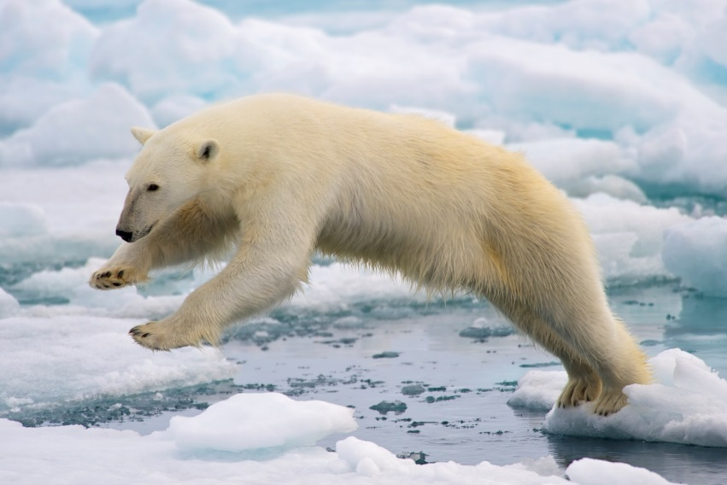The polar bear (*Ursus maritimus*) occurs throughout the circumpolar region on the arctic, with their southern range being determined by the amount of sea ice. They rely heavily on sea ice for almost everything: for feeding, breeding, movement and raising young. The long-term persistence of polar bears is threatened by climate change because warming of the arctic region has meant a drastic reduction in sea ice. Reduction in sea ice has adversely affected both survival and reproduction, threatening survival of these beautiful creatures.

Under the “business as usual” scenario (i.e., if we do nothing to reduce carbon emission), climate change models predict significant warming of the arctic, and drastic reduction in sea ice. A big question then is: what does future hold for polar bears? In an attempt to address this question, Hunter et al. (2010) applied multistate capture-mark-recapture (CMR) models to data collected during 2001 – 2006 and estimated demographic rates for the female segment of a polar bear population in the southern Beaufort Sea (off the coast of Alaska). They used these parameters to construct and analyse stage-structured, deterministic, and stochastic matrix population models.

Vital rates and population projection matrix for each year of the study are given in the associated R file Ex_11_Polar_bear_ltre.R (matrices, A200*X*, where *X* is a year of study). The life cycle graph is given at the end of this document.

**Exercise**

**A. Basic exploration. Perform basic matrix model calculations and provide the following information (and answer the questions) (Part I of the code):**

1. What are the annual population growth rates? When did the polar bear population grew at the highest and the lowest rates? Plot the population growth rates for each year of the study.
2. Calculate year-to-year differences in population growth rates, and plot the results. When did the largest change in λ occur?
3. Calculate the mean, standard deviation, and range of λ across years. What conclusions can you draw based on these results?

**B. Stochastic demography: estimating long-term growth rate of the polar bear population in a stochastic environment (Part Ib of the code)**

1. Calculate stochastic growth rate (Tulja’s approximation, as well as simulations + CI) assuming that (use maxt ≥10000):
   1. Each year (i. e., matrix) occurs with equal probability
   2. The first year of the study occurs more frequently than other years, with prob =c(.3, .2, .2, .2, .1).

What conclusions can you draw from these results?

**C. Understanding year-to-year changes in λ: Fixed effect LTRE analysis (Part II of the code)**

1. Perform 1-way LTRE analysis, comparing population projection matrix for each year with that in the previous year. Examine the relevant results. How good was your LTRE model? How do you know?
2. The biggest change in λ occurred during 2003 - 2004, a drop in population growth rate of 0.27! So, let’s just focus on understanding what caused that decline.
   1. Which entry of the projection matrix made the largest contribution to this decline? How do you know?
   2. Was this decline because of big change in the value or due perhaps to some other reasons? You will have to examine matrix of differences, contribution matrix and perhaps the sensitivity matrix (of the mean matrix) to answer this question.

**D. Understanding how year-to-year changes vital rates contribute to λ: Fixed effect LTRE analysis with lower-level parameters (Part III of the code)**

1. Calculate and plot sensitivity and elasticity of λ to changes in lower-level vital rates for the year 2001. Which vital rate λ is most sensitive to on the absolute scale (sensitivity) and proportional or log scale (elasticity)?
2. Recall that the population growth rate was the lowest for 2004 (see also Table 1 of Hunter et al. 2010):

> growh.rates

[1] 1.0590883 1.0614439 1.0362673 0.7649747 0.7991206

Using vital rates for 2001 as the reference and vital rates for 2005 as treatment, decompose the difference in population growth rate (Δλ = 0.7649747 - 1.0590883 = 0.294) into contribution from vital demographic rates. Compare these results with those presented in Table 2 of Hunter et al. (2010):

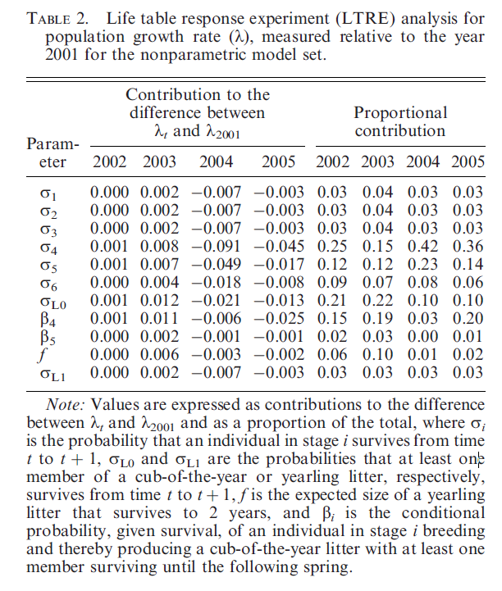

The life-cycle graph to aid in interpretation of the above results:

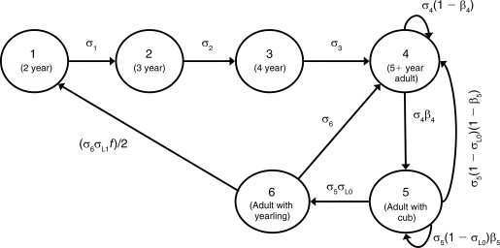

Polar bear life cycle graph: σi is the probability an individual in stage i survives from time t to t + 1, σL0 and σL1 are the probabilities that at least one member of a cub-of-the-year or yearling litter, respectively, survives from time t to t + 1, f is the expected size of a yearling litter that survives to 2 years, and βi is the conditional probability, given survival, of an individual in stage i breeding and thereby producing a cub-of-the-year litter with at least one member surviving until the following spring.

Part IV of the code presents example calculations for the regression design LTRE analysis. It assumes that survival of the youngest stage (σ1) is a affected by a quantitative covariate *x* (e.g., sea ice extent), and derives the functional relationship between σ1 and *x*, and between λand *x*. Explore it on your own.

## Exercise 12: A simple Integrated Population Model

This introduction is based on a simplistic model (in particular, with no census uncertainty), and artificial data. The model is a single age class model and is summarized by the following recurrence equation for population size at time t, $Y_{t}$:

$Y_{t+1}=λY_{t}+ε_{t}=(f+s) Y_{t}+ε_{t}$.

The parameters of the model are a net fecundity 𝑓and an adult survival 𝑠. The population size is multiplied on the average at each time step by $λ=f+s$ and is affected by demographic stochasticity, with $var(ε_{t} )=σ^{2}$, with no uncertainty in the census. This is a major simplification, as the observation $Y_{t}$ is also the state of the system $Y_{t}$. Realistic Integrated Population Models will distinguish the state of the system and the observations.

1. Run the code in file Ex_12_IPM.r for the statistical study of this basic IPM, with successive observed population sizes {100, 110, 120, 135, 148, 160, 175, 188, 200}, and demographic parameter estimates $\hat{s}$ = 0.8200 (s.e. = 0.0040) and $\hat{f}$ = 0.2500 (s.e. = 0.0050).
2. Compare statistically the estimated $λ$ values from counts and demographic parameter estimates, respectively. Are these two estimates of $λ$ compatible? Are they still compatible if $f$ equals 0.20 (with the same s.e.)?
3. Coming back to the original demographic estimates, calculate the percentage of decrease in $var(λ)$ from the demographic-based estimate to the combined one.
4. How do you explain one can improve the estimation of $f$ and $s$ in the IPM while they are not separately estimable based on counts only?
5. Propose a value of the standard error of $f$ to mimic a situation where $f$ is not estimable. Then obtain and discuss the estimates of $λ$ when $f$ is not estimable
6. Coming back to the original estimates of $f$ and $s$ and their s.e., check what happens with observed population sizes 10 times as big as the original ones. Comment.

## Exercise 13a: Exploitation in a Matrix Model with Two Sexes

[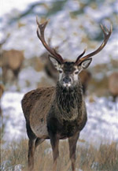](http://www.deer-pictures.com/reddeer-buck.jpg)We consider a matrix population model that could apply to red deer *Cervus elaphus* or similar ungulates, with plausible demographic mechanisms and parameter values for such species. The model considers the two sexes and is used to examine the effect of male harvest on the population dynamics.

The two sexes are assumed to be senescent after age 12. Post-reproductive age classes are not represented because they bear no influence on the population growth rate. Hence, the matrix model has dimension 24 x 24. The model is said to be ‘female dominant’ as only females produce young of the two sexes. However, the probability that a female reproduces is modelled as dependent upon the ratio of reproductive males / reproductive females, and drops when there are too few males, as expected in a polygynous species. This is known as “frequency dependence”; a special case of “density dependence”.

**Exercise**

1. After carefully examining the file Ex_13a_Deer.r, describe the main demographic traits of this hypothetical red deer population that is based on the many studies of this charismatic species.
2. Using the code in Ex_13a_Deer.r, use the two-sex matrix model for red deer and plot the relationship between male harvest rate and asymptotic population growth rate. Inspect the vector of harvest rates analyzed, and the resulting population growth rates, to find the harvest rate that lead to a stationary population. Denoting 0 as the asymptotic growth rate when h = 0, also calculate and plot 0(1-h), which is the population growth rate assuming completely additive effects of the loss of males through harvest on the population growth rate. Comparing your two plots, what can you say about the degree of compensation in the harvest of male red deer at the population level?

## Exercise 13b: Management of Overabundant Cormorant (on your own)

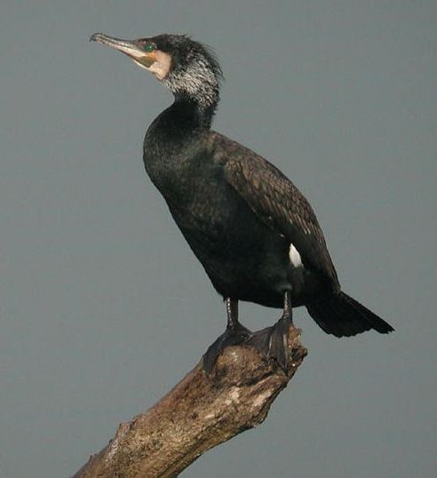Since the early 1970’s, an increase in the number of cormorants *Phalacrocorax carbo* breeding in Northern Europe resulted in an increase in the number of individuals wintering in France. This increase has induced many problems, in particular for fish breeding (aquaculture) in wetland areas of central France; ultimately leading to the establishment of a cormorant management plan. Very similar events have occurred with the double-crested cormorant in North America. The aim of this exercise is to evaluate, through matrix modelling, the effects of various strategies to limit cormorant numbers.

The number of cormorants wintering specifically in France has increased exponentially from the beginning of the 1970's to the 1990's at a rate of 15% per year. Similar increases have been observed in neighbouring countries (15.6% per year in Switzerland, 18% in U.K., 15.9 % in Italy from 1987 to 1994). Populations wintering in Central Europe have also exhibited high growth rates. In addition to parameters described in the R files, average demographic parameters for cormorants in Northern Europe are as follows:

Survival probability from age 0 to age 1 = 0.64

Survival probability from age 1 to age 2 = 0.86

Survival probability from age 2 onwards = 0.89

Proportion of breeders at age 3 = 0.10

Proportion of breeders at age 4 = 0.60

Proportion of breeders from age 5 onwards = 1.00

**Exercise**

1. Using the density-independent matrix model for cormorants in the Ex_13b_Cormorant.r file that is parameterized with the demographic parameters described above (as well as others described in the file), does an annual rate of growth of 15% per year seem plausible?
2. To limit the increase in numbers, a manager might be quite interested in knowing if it would be more efficient to remove eggs from nests or cull individuals capable of flight. By lowering the cs and cf variables, one at a time (e.g., changing each one from 1 to 0.9), which type of management action would lead to the largest reduction in population growth rate given equivalent percentage changes in clutch size vs. survival? What is the general rule explaining your findings?
3. The assumption of exponential growth is strong and will not be relevant in the long-term. There is no doubt that regulation through a density-dependent reduction of fertility or survival should eventually occur. Indeed, such a regulation may have already been present in Northern Europe after the year 2000. In order to model a density-dependent process, we can multiply nestling survival (commonly limited by per capita food availability) by a function that decreases exponentially as a function of the number of breeding females. By looping through alternative values of the density-dependent coefficient for nestling survival B, use the second piece of code in Ex_13b_Cormorant.r to find the value of B that would lead to an equilibrium number of breeding females (nbc) equal to 20,000.
4. In the density-dependent environment, estimate the percentage reduction in fecundity or survival required to decrease the equilibrium population size by approximately 20 % (i.e., ~20,000×0.8; use the value of B that resulted in your answer for question 3 above).

## Exercise 14: Whooping Crane PVA

An important goal of conservation biology as a discipline is to identify and quantify threats faced by species of conservation concern, and to take appropriate management actions to mitigate threats. But what do we mean by *threats*? How does one go about identifying and quantifying *threats*? In the context of species conservation, a threat typically implies threat to the persistence or wellbeing of a species or population of conservation concern. And threats to species are usually assessed and quantified using a set of quantitative tools, collectively called *Population Viability Analyses (PVA)*.

You have learned about the fundamentals of PVA from the lecture, but let’s briefly review the PVA. Broadly, PVA involves the following steps:

1. ***Identification of objectives/questions***: Why do you want to conduct a PVA? To assess relative risk? Absolute risk? To evaluate alternative management strategies? Just for heuristic purposes? Clearly defined objectives or questions are very important because analyses are performed, and results are interpreted in the context of objectives/questions.
2. ***Selection of a model and model structure*:** Type of appropriate models/modeling framework depends on the available data and objectives/questions. We will revisit it later.
3. ***Estimating parameters for the PVA model:*** Depends on steps 1-2.
4. ***Running the model:*** Depends on steps 1-3.
5. ***Sensitivity analysis, scenario planning:*** Depends on steps 1-4.
6. ***Evaluation and interpretation of results and assumptions:*** Depends on steps 1-5.

So, this was a quick review of what you already know from the lecture. Enough of that – time to learn how to actually conduct PVAs. As a conservation biologist and wildlife manager, it is your job to determine what questions or objectives you wish to address using a PVA or if PVA is even necessary. Here, we focus on technical aspects: for a given data type, how do you go about performing a PVA to estimate population growth and persistence parameters?

Let’s begin with simple methods that utilize time series of abundance or count data – like the whooping crane dataset you are already familiar with. Morris and Doak (2002) call PVAs that utilize this type of data “***count-based PVA***”. Since you are already familiar with the whooping crane dataset, we will use it as an example to demonstrate two alternative PVA methods appropriate for count data: diffusion approximation and simulation-based PVA. Take a moment to review the whooping crane data, and the analyses that you performed earlier.

We begin with what we already know: stochastic exponential growth model. To implement the stochastic exponential growth model, we assume that the *per capita* population growth rate *r* is normally distributed, with specified mean and variance. Then, at every point in time we sample a value of *r*, and project the population size to the next step until *t_max*. These procedures will yield one simulated population trajectory. We can then repeat these procedures many times to generate 100’s or thousands of simulated trajectories. This task can be easily achieved by writing a simple function in R. Review of the first chunk of the code in Ex_14_Whooping_crane_pva.R, where we develop a function to implement stochastic exponential growth model. This function takes mean *r* (r_mean), standard deviation of *r* (r_sd), starting population size (N0), and point in time for which to project population size (t_max) as input arguments, and returns a matrix of simulated population size.

The next step is to read the data and estimate the population parameters that are needed to run the function. We already know how to do that (simple ratio method will do just fine. Let’s run the simulation for 200 years (t_max = 200) and produce 500 simulated population trajectories (sims = 500). Finally, you can plot the simulated trajectories to, and analyze the population trajectories to calculated the probability of (quasi)extinction, mean time to extinction, extinction time cumulative distribution function (CDF) and other extinction parameters as needed. models.

To calculate the extinction parameters, all we have to do now is to follow a few simple steps:

1. Define **the threshold critical population size** such that, if a population falls below this threshold, the population is considered to be quasi-extinct. This determination must be made based on your knowledge of species’ life history and population dynamics.
2. Examine each trajectory, and check to see if the population size falls below **the threshold or critical population size**.
3. If it does not, there is nothing to be done – the simulated trajectory does not go quasi-extinct. If it does, do the following:
   1. Increase the extinction counter by 1;
   2. Record the point in time when the simulated population trajectory fell below the critical threshold. Save that information, because it will be subsequently used to calculate the mean or median time to extinction, and to examine the distribution of extinction times.
   3. If a trajectory falls below the critical threshold, consider that trajectory extinct and set it to zero from that point forward. This will help you keep track of the trajectories that have already gone quasi-extinct.
   4. Output extinction counter and a vector of extinction time for further analyses.
4. If none of the trajectories fall below the threshold, conclude that the population has a zero probability of extinction/quasi-extinction for the given parameter values and time frame used.
5. If one or more trajectories do go quasi-extinct:
   1. Calculate the probability of quasi-extinction as: (number of trajectories that go quasi-extinct)/(total number of simulations).
   2. Analyze the extinction time vector as necessary. Note that if the probability of quasi-extinction is zero (i.e., no trajectories go extinct) then the extinction time vector is empty, and no further calculations are possible or necessary!
6. Plot the “updated” trajectories if desired.

That’s pretty much it! Let’s go ahead and implement these steps and see what we find for the hypothetical population with the above parameters. Note that in our example calculations, the matrix out is a matrix of population trajectory produced by our R implementation of stochastic exponential population growth model, and each column of the matrix is one population trajectory. Note that this approach estimating extinction parameters is very general and is applicable to trajectories generated by ANY type of population, ranging from simple exponential growth model to very complex matrix or individual-based population.

**Exercises**

* 1. Report the mean and SD of the per capita population growth rate *r*, . What do these values, along with the plot of the population size time series, tell us about the whooping crane population dynamics?
  2. Assume that the critical population size or extinction threshold for whooping cranes is 15 (N_critical = 15). Calculate and report probability of quasi-extinction and mean and median time to extinction (Note: it is possible that some of these results are 0 or NA.). What can you say about the dynamics and persistence of this population of whooping cranes? Why do you think you are getting these results?
  3. Perform the PVA for the following parameter values: sims = 1000, t_max = 200, r_mean = -0.01, r_sd = 0.01, N0 = 100, and N_critical = 15. Plot the population trajectories.
     + 1. Calculate and report the probability of quasi-extinction, and median time.
       2. Plot histogram of the distribution of extinction time, and extinction time CDF
       3. Interpret your PVA results.
  4. Repeat Exercise 3, and see how results might change if you (1) reduced value of r_mean, (2) increased value of r_sd, (3) doubled t_max, (4) increase sims = 10,0000.

Part II of the code implements stochastic differential equation model (SDE; AKA Weiner-drift model), described in detail by Dennis et al. (1991). If interested, read the paper and work through the code. This is a theoretically sound approach to conducting PVA for a population that approximates exponential growth.

## Exercise 15: Polar Bear PVA

Unstructured population models (including those used for PVA above) assume that all individuals in a population have the same birth and death rates. While this assumption simplifies things to some extent, we know that it does not hold true in most natural populations. In this exercise, we will now use stochastic of matrix population models to perform (structured) PVA. You know all about the matrix models; the only difference is that we now consider matrix models in variable environments – that is, we will explicitly consider environmental stochasticity.

Conceptually, stochastic matrix models have 3 components:

* 1. ***A ‘model’ for the environment****:* In order for us to know how variation in the environment affects population dynamics, we first need to know how the environment changes over time. Because variation in the environment can affect different species differently, you may need a different environmental model for different species.
  2. ***Environmental influence on vital rates:***Next thing we need to know is: how does environmental variation affect vital demographic rates? Basically, we need a set of vital rates associated with each environmental state. In the snail kite example, we would like to have a set of vital rates (equivalently, a population projection matrix) associated with the dry years, wet years and normal years.
  3. ***Analysis:***Analysis of stochastic matrix models involves: (i) drawing each environmental state and associated demographic parameters (or projection matrix) for each time step, (ii) performing population projections, and (iii) calculating population growth and extinction parameters. These steps are conceptually similar to the steps we used for unstructured PVA earlier in this section.

If we ignore mathematical details (which can be hairy) it’s not hard at all, especially if we allow R to do all the calculations for us. For this exercise, we will use the polar bear data that we used in exercise 8; take a moment to re-read the paper and review these data and re-acquaint with the data and issues at hand before proceeding with the exercise. Note also that population growth rate (year-specific, as well as means and variances) and elasticities also provide useful information regarding the population dynamics and persistence, so revisit those calculations from the previous exercise. Here, we will focus on calculations related to extinction parameters.

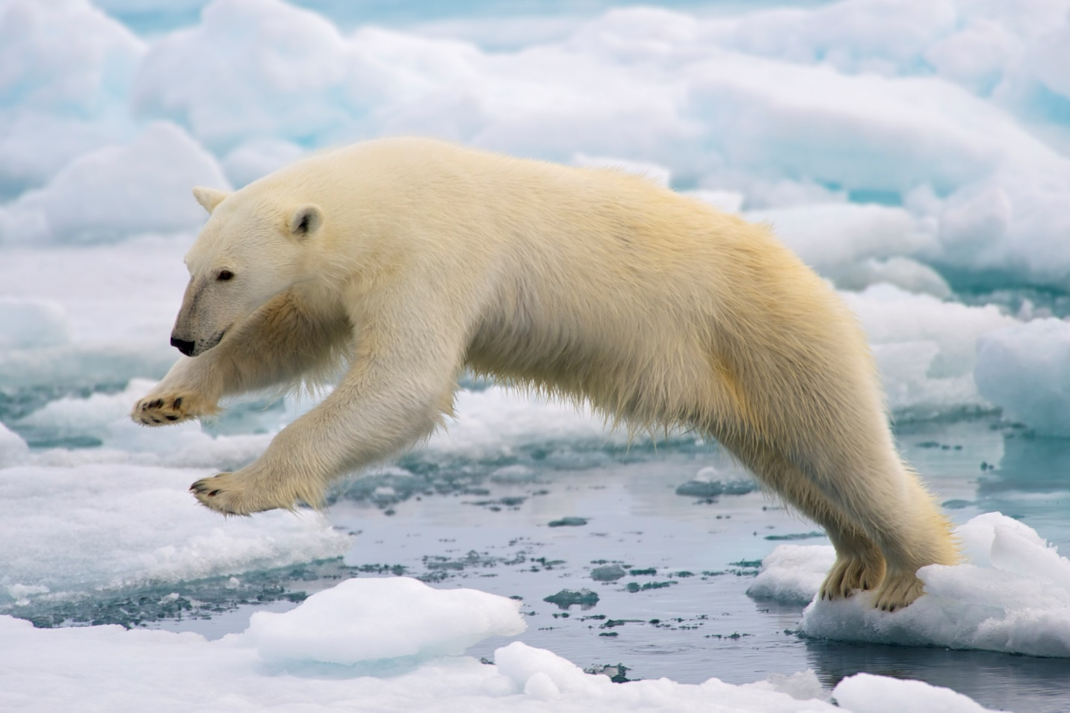

Data are summarized in the file polar_bear_data.csv, and code file is Ex_15_Polar_bear_pva.R. You can use the following code fragment to read the data and extract stage-structured population projection matrix for each year of the study, and a create a list of matrices, which will be used for calculation of stochastic population growth and extinction parameters.

> p.bear = read.csv("polar_bear_data.csv", header = FALSE)

> p.bear.A01 = as.matrix(p.bear[1:6,])

> p.bear.A02 = as.matrix(p.bear[7:12,])

> p.bear.A03 = as.matrix(p.bear[13:18,])

> p.bear.A04 = as.matrix(p.bear[19:24,])

> p.bear.A05 = as.matrix(p.bear[25:30,])

> polar.bear.matrices = list(A2001, A2002, A2003, A2004, A2005)

For these exercises, we will explore two *popbio* functions: *stoch.projection* for stochastic population projection, and *stoch.quasi.ext* for calculation of quasi-extinction probabilities. Explore these functions and learn about input and output arguments.

Hunter et al. (2010) report that the number of polar bears in the southern Beaufort Sea estimated in 2006 was 1526. They also report that the population stage structure for 2004-2006 was (see Hunter et al. for details): 0.106, 0.068, 0.106, 0.461, 0.151, and 0.108, respectively.

**Exercises**

1. Assuming that the environment observed during each year of the study occurs with equal probability (call it *p_eq* scenario):
   1. Calculate and interpret the stochastic growth rate.
   2. Project the population size for 100 years and plot the ending population size. Interpret the results.
2. Perform PVA under the *p_eq* scenario. Report and thoroughly interpret all relevant results, including the probability that the population will go quasi extinct within the next 20, 30, and 50 years. Report all relevant plots, summary statistics etc.
   1. What do you conclude regarding the dynamics and persistence of the polar bear population? Provide supporting evidence and justify your results.
   2. Knowing what you know about the global climate change and its impact on the polar environment, what would be your recommendations for the management of polar bear population to ensure its long-term persistence? Again, provide supporting evidence and justify your answer.

**Alternative Scenarios for the Environment:**

Virtually all climate change models predict that the frequency of extreme conditions would significantly increase in the future. For polar bears, it would mean that the poor ice conditions – similar to those observed in 2004 and 2005 - will occur more frequently.

1. Repeat analyses in 2-3 above, assuming that
   1. Poor ice conditions occur 50% of the time;
   2. Poor ice conditions occur 60% of the time;
   3. Answer questions in exercises 1-2 under these assumptions. What are your overall conclusions?

See Eq. 4 in Hunter et al. (2010) on how to calculate environmental probability vectors.

1. Based on what you have learned about PVA, can you summarize the steps that are needed to calculate extinction parameters using stochastic matrix models? Write a code to perform the relevant calculations and return the results that are most relevant to your study. That way, you don’t have to rely on what popbio functions can do; you can modify your code to do what you need to do for your particular study.

# SOLUTION TO EXERCISES

## Solutions to Exercise 1: The exponential population growth model

1. *On your own. Simply change the relevant values and rerun the code.*
2. *Whooping crane population dynamics.*
3. *Calculate the annual finite (λ) and continuous time (r) population growth rates. When did the population grew at the highest rate, and when did it grow at the lowest rate? Can you speculate about why those years were the best and the worst years for the whooping crane population?*

Simply make a table of year, λ and r, and look for highest and lowest values. We see that the population growth rate was lowest during 1990-1991 (10% annual decline), and highest during 1994-1995 (19% annual growth).

While on their breeding grounds in Canada, whooping cranes primarily feed on snails, crustaceans, aquatic insects, and small aquatic vertebrates (fish, frogs etc). While on the wintering grounds (US Gulf Coast), they primarily feed on crabs and clams, but also consume snails, crustaceans, aquatic insects, and small aquatic vertebrates. We can speculate that good wetland conditions in their breeding and summer grounds potentially led to high growth rates, whereas poor wetland conditions caused poor growth rates.

> Year = cranes2$Year[-length(cranes2$Year)] #exclude the final year

> growth.by.yr = as.data.frame(cbind(Year, lambda, r))

> growth.by.yr

Year lambda r

1 1990 0.9041096 -0.100804699

2 1991 1.0303030 0.029852963

3 1992 1.0514706 0.050189745

4 1993 0.9300699 -0.072495502

5 1994 1.1879699 0.172245905

6 1995 1.0126582 0.012578782

7 1996 1.1375000 0.128832872

8 1997 1.0054945 0.005479466

9 1998 1.0109290 0.010869672

10 1999 0.9567568 -0.044206093

11 2000 0.9830508 -0.017094433

12 2001 1.0632184 0.061300526

13 2002 1.0486486 0.047502334

14 2003 1.1134021 0.107420249

15 2004 1.0092593 0.009216655

16 2005 1.0871560 0.083565078

17 2006 1.1223629 0.115436168

18 2007 1.0150376 0.014925650

19 2008 0.9740741 -0.026267927

20 2009 1.0684411 0.066200637

1. *Calculate the mean and variance (or SD) of the finite and continuous time population growth rates. What do the mean and variance of population growth rate tell you about whooping crane population dynamics? What do you think would happen if the SD of the population growth rate was twice as high? What would be the conservation implications?*

During the study period, the population grew at an average rate of 3% per year, but that the growth rate was quite variable as indicated by SD(λ) = 0.07. Variance of population growth rate generally indicates the degree of uncertainty in population dynamics due to environmental stochasticity (and sampling variance). Generally speaking, higher the variance of population growth rate, greater the uncertainty in population dynamics, and higher the probability of extinction or quasi-extinction. We will learn more about these concepts later in the workshop.

> mean(lambda)

[1] 1.035596

> var(lambda)

[1] 0.005077795

> sd(lambda)

[1] 0.07125865

> mean(r)

[1] 0.0327374

> var(r)

[1] 0.004708117

> sd(r)

[1] 0.06861572

1. *Based on the mean population growth rate, calculate the doubling and tripling times. Do you think this population will continue to increase at the same rate forever? Why or why not?*

If the population growth continued at the mean observed growth rate, the whooping crane population will double in about 21 years, and triple in 34 years. However, it is unlikely that the exponential growth will continue. As the population size increases, competition for food, nesting sites and other resources will also increase; ultimately, there will not enough resources for all which can increase death rate, reduce birth rate or both.

> log(2) / mean.r

[1] 21.17294

> #time for populations to triple in size

> log(3) / mean.r

[1] 33.55832

1. *Plot the observed and model-predicted whooping crane abundance data, and briefly comment on the fit of the exponential population growth model to these data.*

The observed vs. model-predicted plot indicates a generally good fit of the exponential growth model to observed data

## Solutions to Exercise 2: The logistic population growth model

1. *What are the estimated values for rmax, SD(rmax) and K? How would you interpret these results?*

The maximum continuous time growth rate for China’s population is 0.051, with finite annual growth rate λ = er = 1.053 or 5.3% annual growth. The relatively small SD(*rmax*) suggests relatively high precision (or low uncertainty) in this estimate. The model-predicted equilibrium population size is about 1.47 billion.

> r_max_china

[1] 0.05158749

> r_sd_china

[1] 0.002190967

> K_china

[1] 1465498065

1. *If the population had gone on increasing at the rate of rmax and, how long would it take the population to double and triple in size? Why do you suppose China’s population did not continue increase at the same rate?*

Under that scenario, the population would have doubled in 13 years and tripled in 21 years. Obviously, that did not happen; no population is expected to grow at the rate *rmax* for very long, even under ideal conditions (no resource limitation, or negative effect of high population size etc). In China, one child policy was aggressively implemented by the government which curbed the population growth rate effectively soon after the policy was implemented.

> log(2)/r_max_china

[1] 13.43634

> log(3)/r_max_china

[1] 21.2961

1. *Based on the relevant plots (e.g., observed vs. predicted population size, plot of r vs. N), how good is the model fit? Do you think China’s human population followed a logistic growth during the study period?*

The plots of r vs. N, and observed vs. predicted population size (codes in the R file) indicated good fit of the model to data. If you plot observed vs. predicted population size for a longer period (see solution to next, the fit looks excellent!

1. *Project and plot the population size for 100 years. What is the model-predicted population size in the year 2021 and 2100?*

See below. To answer the second part of the question, you can simply make a data frame of year and predicted population size, and look for population size value for the year 2100 (result not shown). Examining this data frame, we find that model-predicted population size in 2021 is 1.39 billion, which compares favorably with estimated population size for 2020 (1.44 billion). The model predicted population size for 2100 is 1.46 billion.

> as.data.frame(cbind(t + 1960,N_t))

> plot(t + 1960,

+ N_t,

+ type = 'l',

+ col = "blue",

+ xlab = "Year",

+ ylab = "Population size",

+ cex = .8,

+ cex.main = 1.5,

+ cex.lab = 1.5,

+ lwd = 2,

+ cex.axis = 1.5

+ )

> points(data$Year,data$Population, col = "red")

## Solutions to Exercise 3: Life table analysis

Explore the data and code on your own.

## Solutions to Exercise 4: The barn swallow matrix model

*1. Draw the life cycle of this species, making fledglings appear explicitly in your diagram*.

You might have drawn this as something like the following as shown in the lecture

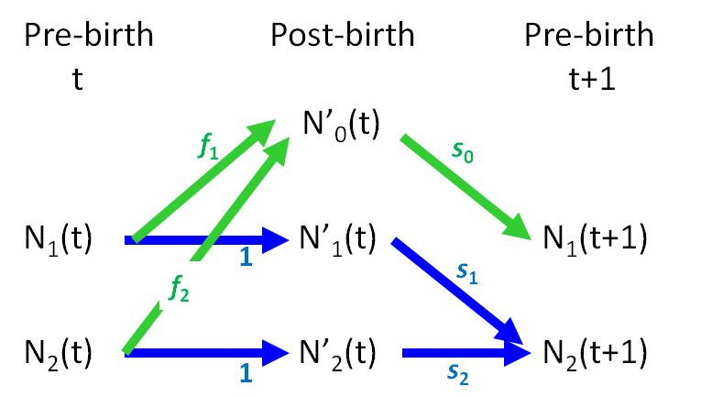

or you might have drawn something like this

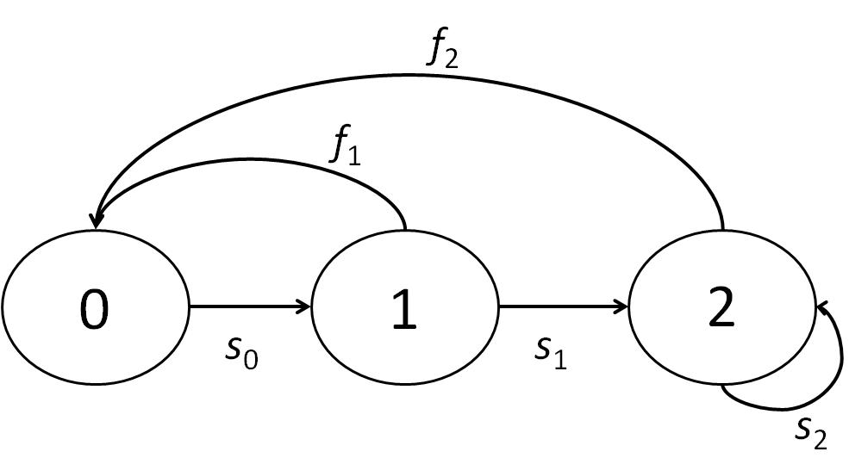

*2. Write the corresponding matrices for the pre-birth-pulse and post-birth-pulse models.*

The seasonal life cycle shown above is more useful in guiding construction of either the pre- or post- birh-pulse models (alternatively, one could draw separate bubble-arrow diagrams). From the seasonal life-cycle one gets seasonal matrix projection models:

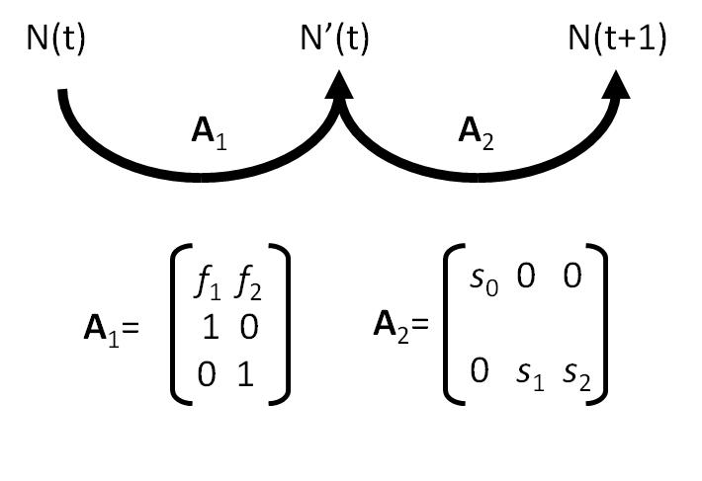

In turn, these can be used to construct the 2 x 2 annual pre-birth-pulse matrix model: **A**2 x **A**1 =



or the 3 x 3 annual post-birth-pulse matrix model: **A**1 x **A**2 =



The order of the matrices in a matrix product is from right to left, the order of time (e.g., pre-birth pulse, first **A** 1, then **A** 2, hence product **A** 2 x **A** 1).

*3. Inspect the first piece of code to see if you can interpret what it does; then run the code and inspect the output to see if you understand the code correctly. What happens to population growth rate over time?*

You find that the annual population growth rate (gr; pop size at time t/pop size at time t-1) converges to a value of 1.05 by the 6th time step and remains there. The property of independence of the long-term growth rate in a deterministic environment for structured populations is formalised in the strong ergodic theorem. This, and additional theory, will be addressed later.

*4. The next piece of code allows you to loop through two different sets of initial values: n1 = 10, n2 = 0; then n1 = 0, n2 = 10. The code for the graphs provides comparisons of the age-specific abundances, total abundances, and population growth rates for the different initial conditions. What happens to the population growth rates and total abundances over time?*

In the graphical output provided by the code you ran (and can modify), we confirm what was observed in the first step: the population growth rate converges to 1.05 regardless of the initial conditions. However, the population abundances are affected by the initial conditions; they never converge to the same value. The two populations with different initial conditions eventually grow at the same rate but that which starts with more AFY birds has a higher total abundance in the long run. Later, we will discuss the theoretical reasons for why this occurs.

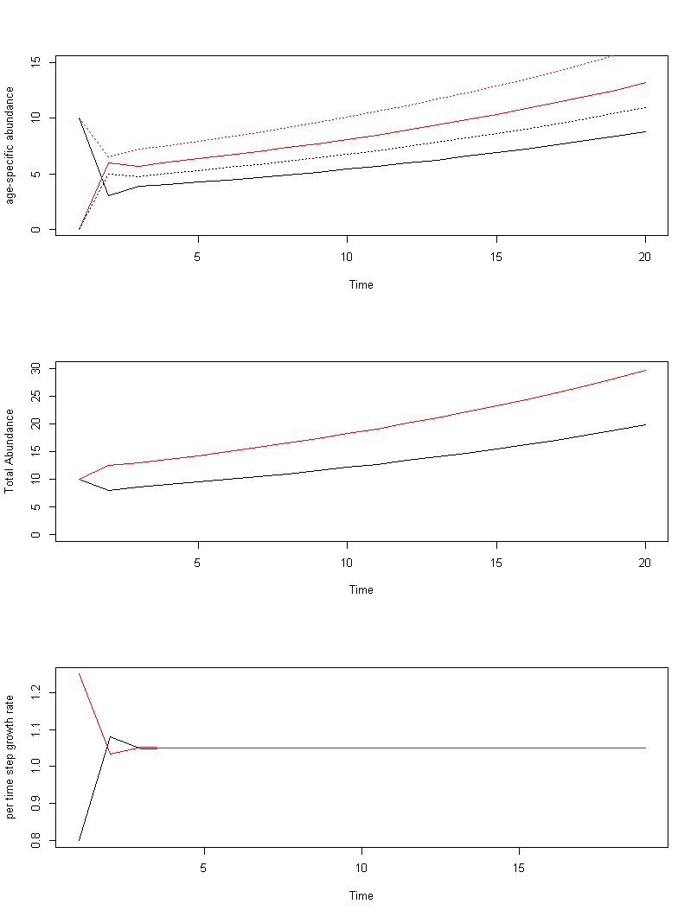

*5. Now see if you can develop a graph that plots the abundance of one age class against the other (n1, n2) for each of the initial conditions. This is called a “phase plane”, and is one way to view convergence of the population’s age structure to the stable age structure.*

Following step 4, all you need to add is the following code (which can be modified to adjust graphic properties)

*# create phase-plane plot*

plot(n[1,],n[2,],type="l",xlab="FY females",ylab="AFY females",

main="Phase Planes",xlim=c(0,10),ylim=c(0,10))

lines(n[3,],n[4,],col="red")

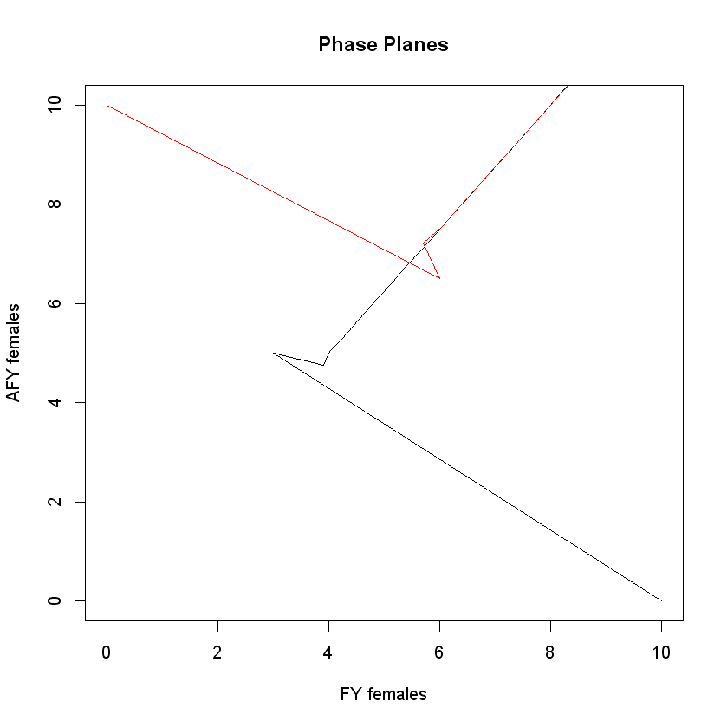

*6. Now adjust the code to examine the population dynamics for the post-birth-pulse model, and compare to dynamics of the pre-birth-pulse model from above. You could just change a few lines of code, or you could ‘copy’, ‘paste’ and then adjust the code.*

The following adjustments in the code would be needed for the post-birth-pulse matrix model:

Note that we are dealing at once with the two different initial conditions, but you can treat them separately to make the code simpler

*# Create the post-birth-pulse swallow matrix population model*

A <- matrix(c(

f1*s0, f2*s1, f2*s2,

s0, 0, 0,

0, s1, s2), nrow = 3, byrow = TRUE)

tspan <- 20 *# time span for projections*

rows <- dim(A)[1]

cols <- dim(A)[2]

*# Build some matrices for storing eventual output*

n <- matrix(0,rows*2,tspan) *# storage of age-specific abundances*

N <- matrix(0,tspan,2) *# storage of total abundances*

gr <- matrix(0,tspan-1,2) *# storage of time-specific population growth rates*

n[,1] <- c(0,10,0,0,0,10) *# initial population abundances in each age class*

*# for two different initial conditions*

*# Project population forward for each initial condition and store output*

for (j in 1:2) { # j is for the initial condition

N[1,j] <- sum(n[(j*3-2):(j*3),1]) # treat the first time separately

for (t in 1:(tspan-1)) { # t is for time

n[(j*3-2):(j*3),t+1] <- A%*%n[(j*3-2):(j*3),t]

N[t+1,j] <- sum(n[(j*3-2):(j*3),t+1])

gr[t,j] <- sum(n[(j*3-2):(j*3),t+1])/sum(n[(j*3-2):(j*3),t])

}

}

par(mfrow=c(3, 1)) *# Set graphics window to 3 rows with 1 column*

plot(1:tspan,n[1,],type="l",xlab="Time",ylab="age-specific abundance",

ylim=c(0,40))

lines(1:tspan,n[2,],lty=3)

lines(1:tspan,n[3,],lty=4)

lines(1:tspan,n[4,],col="red")

lines(1:tspan,n[5,],lty=3,col="red")

lines(1:tspan,n[6,],lty=4,col="red")

plot(1:tspan,N[,1],type="l",xlab="Time",ylab="Total Abundance",ylim=c(0,50))

lines(1:tspan,N[,2],col="red")

plot(1:(tspan-1),gr[,1],type="l",xlab="Time",ylab="per time step growth rate",

ylim=c(1,2.6))

lines(1:(tspan-1),gr[,2],col="red")

*# create phase-plane plot*

plot(n[2,],n[3,],type="l",xlab="FY females",ylab="AFY females",

main="Phase Planes",xlim=c(0,10),ylim=c(0,10))

lines(n[5,],n[6,],col="red")

## Solutions to Exercise 5: Sampling variance of growth rate

1. *Check how a matrix filled in using simulated replicates of the parameter estimates is repeatedly obtained in a simulation loop, which is itself within a loop scanning the 4 scenarios.*

In the simulation loop, at each step, random normal deviates are drawn and multiplied by the standard deviation of the corresponding parameter to produce simulated values of the parameters, used to produce at each step a random replicate of the original matrix, whose dominant eigenvalue is calculated and stored. This is done for each scenario, through the external loop on scenarios.

1. *Do you find that the way the repeats of the dominant eigenvalue of these simulated matrices are statistically treated is complex or simple?*

One just calculates the mean and standard error of the simulated growth rates, and the histogram is plotted, so the overall treatment is simple. The only precaution at this stage is to take enough replicates for the simulation to be reliable (several thousand)

For what follows, we need simulation results, which will differ among different simulations, and below is just one set of results. Yours may differ slightly. Here is just an example over 5000 simulated replicates:

growth rates (dominant eigenvalue)

baseline, averages under scenarios 1, 2, 3, 4

1.0500 1.0478 1.0497 1.0475 1.0494

standard errors

0 0.0897 0.0166 0.0926 0.0405

P-level of normality tests (Lilliefors)

lambda , scenarios 1, 2, 3, 4

0.0384 0.5000 0.3447 0.0113

log(lambda), scenarios 1, 2, 3, 4

0.0010 0.2926 0.0010 0.0010

1. *Based on the results of the Lilliefors tests for normality, can we use a test on the multiplicative growth rate $λ$ or is it preferable to do so on the growth rate $r=log⁡(λ)$?*

Clearly, in this example, the growth rate is more normally distributed than the log growth rate. This is far from being the dominant situation (Houllier et al. 1989) as in many cases, the growth rate will have a skewed distribution, less so after being iog-transformed.

1. *In which scenario can we decide the population is significantly growing?*

Again, the results may vary from one set of simulations to another, but it is only in scenario 2 that the sampling variance of lambda is sufficiently small to make $z={(\hat{λ}-1)}/{σ(\hat{λ})}$ significant. In the set of results presented here, z= 2.99. Note that the mean of the simulated growth rate slightly differs from $λ=1.05$ as the dominant eigenvalue is a nonlinear function of the parameters, and its expected value differs from the dominant eigenvalue of the matrix based on the mean parameter values, i.e., the estimates provided.

1. *Which parameter would you recommend to estimate more precisely in the field?*

Clearly here, the sampling variance of the growth rate is high in all scenarios (1, 3, 4) in which some sampling variability of FY survival is considered. Thus, this FY survival probability (and fecundities) have to be more precisely estimated if one wants to increase the precision on the estimated growth rate.

1. *How would you modify the code if the 4 estimates were accompanied by a 4 x 4 sampling covariance matrix $Σ$, i.e; were no more independent.*

Instead of generating at each simulation steps three N(0,1) deviates, $x$, $y$, and $z$, to get the three simulated survival probabilities $s_{0}+xσ_{0}$, $s_{1}+yσ_{1} and s_{0}+zσ_{3}$, one has to draw a random vector distributed as $N_{3}(0_{3}, Σ_{3,3})$ (where the indices give the dimensions) to add to the vector of the three parameter estimates. The R function rmvnorm(n, mean, sigma) (for “random multivariate normal) will do that for you.

## Solutions to Exercise 6: Perturbation analysis of the white stork model

*1. …Examine the matrix model and draw the corresponding life cycle.… To three decimals write down the growth rate on paper or in a spreadsheet.*

**λ = 1.016**

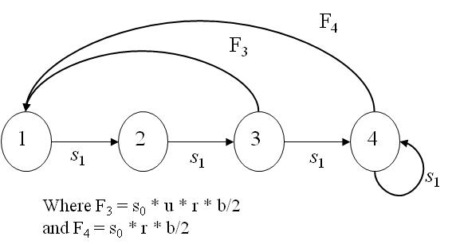

*2. Emulating the decline in survival that was observed (but difficult to estimate precisely), decrease survival after the first year by 20% such that s1+ = 0.8*0.75 = 0.6 (just make this change in the code) and re-run the first piece of code. Calculate the change in population growth rate, relative to the change in survival, by performing the following numerical calculation where abs refers to the absolute value of a difference:*



Parameters not shown in the following tables were never changed in parts 2, 3 and 4

|  |  |  |  |  |  |
| --- | --- | --- | --- | --- | --- |
|  | *s0* | *s1+* | *b* | λ | Relative Change |
| original | 0.482 | 0.75 | 2.9 | 1.016 |  |
| new | 0.482 | 0.6 | 2.9 | 0.843 | **0.851** |

Relative change is calculated as (1.016-0.843)/1.016*0.75/(0.75-0.6) = 0.851

3. *Change after-first-year survival back to the original value of 0.75. Now repeat the same exercise for first-year survival such that the new s0 = 0.8*0.482 = 0.3856. Add the calculated ‘change in population growth rate, relative to the change in survival’ to that from part 2 in order to quantify the total effect of change in survival.*

|  |  |  |  |  |  |
| --- | --- | --- | --- | --- | --- |
|  | *s0* | *s1+* | *b* | λ | Relative Change |
| original | 0.482 | 0.75 | 2.9 | 1.016 |  |
| new | 0.3856 | 0.75 | 2.9 | 0.982 | **0.167** |
| Total rel. change |  |  |  |  | **1.018** |

4. *Change first-year survival back to 0.482, and repeat the same exercise for the number of fledglings produced per successful pair per year such that b = 0.8*2.9 = 2.32.*

|  |  |  |  |  |  |
| --- | --- | --- | --- | --- | --- |
|  | *s0* | *s1+* | *b* | λ | Relative Change |
| original | 0.482 | 0.75 | 2.9 | 1.016 |  |
| new | 0.482 | 0.75 | 2.32 | 0.982 | **0.167** |

5. *Although the changes made to the demographic parameters in steps 2, 3, and 4 were relatively large, do you think you were approximating the sensitivities or the elasticities of the population growth rate to change in the underlying demographic parameters? How would you go about numerically calculating the other perturbation metric?*

These were numerical approximations to the ‘elasticities’. We can infer this because we were comparing the ‘relative’ change in population growth rate to the ‘relative’ change in the demographic parameter. A more exact approach would be to induce small proportional changes in the demographic parameters. Or, just use calculus and calculate derivatives on the log scale to ‘measure the effects of small proportional changes’.

To numerically approximate the sensitivities, one would use an equation like the following



To calculate exact sensitivities, one would calculate the derivative of population growth rate with respect to a demographic parameter on the absolute scale.

*6. Set all demographic parameters back to their original values. Compare your calculations from steps 2 – 4 to the exact analytical calculations by running the second piece of code. Note that the reproductive values and stable age distribution are also calculated because they are components of sensitivities and elasticities.*

*# attain total sensitivity and elasticity to change in overall survival*

totalSsens <- sum(llsenselas[4:5,2])

totalSsens

totalSelas <- sum(llsenselas[4:5,3])

totalSelas

|  |  |  |  |
| --- | --- | --- | --- |
|  | Sensitivity | Elasticity | Approximation |
| *s0* | 0.335 | 0.159 | 0.167 |
| *s1+* | 1.14 | 0.841 | 0.851 |
| total | 1.475 | 1 | 1.018 |
| *b* | 0.056 | 0.159 | 0.167 |

Wow, our numerical approximations to the elasticities were surprisingly close! This means that the relationships between population growth rate and these demographic parameters are close to linear.

Note that the elasticity to (a simultaneous change in all) survival parameters is equal to 1; this will be discussed in the lecture portion of the workshop.

*7. Discuss the relative effects of changes in survival vs. reproductive output on population growth rate of long-lived white storks.*

*# calculate how many times greater the elasticity to change in overall survival*

*# is relative to overall fledgling production*

totalSelas/llsenselas[3,3]

The elasticity of white stork population growth rate to a proportional change in survival across all ages (1) is approximately 6 times greater than the elasticity for fledgling production across all ages. This implies that a ~ 60% change in fledgling production would be needed to achieve the same effect on population growth rate as a 10% change in survival.

*8. If you have time, run the second piece of code for the short-lived barn swallows from Exercise 1 in order to calculate their sensitivities and elasticities for the analogous demographic parameters, then compare to the white stork.*

*# Barn Swallow application*

swallow.vr <- list(f1=1.5,f2=3,s0=0.2,s1=0.5,s2=0.65)

swallow.A <- expression(s0*f1, s0*f2,

s1, s2)

*# then apply the following popbio function*

llsenselas <- vitalsens(swallow.A,swallow.vr)

llsenselas

*# total sensitivities and elasticities*

totalSsens <- sum(llsenselas[3:5,2])

totalSsens

totalSelas <- sum(llsenselas[3:5,3])

totalSelas

totalfsens <- sum(llsenselas[1:2,2])

totalfsens

totalfelas <- sum(llsenselas[1:2,3])

totalfelas

|  |  |  |
| --- | --- | --- |
|  | Sensitivity | Elasticity |
| *s0* | 1.826 | 0.3478 |
| *s1* | 0.5217 | 0.2484 |
| *s2* | 0.6522 | 0.4037 |
| total | 3 | **1** |
| *f1* | 0.06957 | 0.09938 |
| *f2* | 0.08696 | 0.2484 |
| total | 0.157 | **0.348** |

Although the elasticity to (a simultaneous change in all) survival parameters is again equal to 1, the elasticity to changes in fledgling production in this short-lived species is more than twice as large as in the long-lived storks. An explanation for this difference will be developed in lecture.

## Solutions to Exercise 7: Two-site matrix models for black-headed gulls

*1. Find the long-term population growth rate using the* ***popbio*** *package, then by calculating the dominant eigenvalue of* ***A*** *in order to**check that the population is close to stationary.*

The population is close to stationary with λ = 0.997

*2. Run the following lines of code that calculate the stable age-by-location distribution and the reproductive values. Comment on the reproductive values at age 1 for the two sites.*

The reproductive values at age 1 (since we are in a pre-birth-pulse formulation), are 0.08 and 0.07, for Good and Bad locations, respectively. Although the connection by juvenile dispersal between the two sites make the numbers in the two sites grow at the same asymptotic rate, individuals born in the two sites differ in their contribution to growth, as measured by reproductive value. The dispersal is moderate, so an individual born in a Bad location will on average stay in that location and experience a lower average demographic performance than one born in the Good location, even if it has some chance to moving to Good. The juvenile dispersal does, however, make the reproductive values closer to one another than they would be in the absence of exchange among the colonies.

*3. Conduct an elasticity analysis for the lower-level parameters in order to obtain T, the generation time, as described in the lecture.*

The most straightforward way to calculate generation time as a function of elasticities, is to calculate the inverse of total elasticity to an “immature parameter” in the fertility component of the matrix model. Here the elasticity to an overall change in such a parameter can be obtained as the sum of the elasticities to sg0 and sb0, i.e. 0.09756 + 0.03243 = 0.12999. Hence T = 1/0.12999 = 7.69 years.

T <- 1/(llsenselas$elasticity[1]+llsenselas$elasticity[9])

*4. Calculate the elasticity for adult survival, and use it to predict the change in λ that would occur if adult survival (s) were changed from 0.82 to 0.89, a change that seems plausible from data collected between 1985 and 1993. This can be done using the approximation: % change λ ≈ % change vital rate × elasticity, and λpredict = λoriginal × relative change in λ. Using the changevar command, induce this change and compare your predicted λ to the actual λ, and discuss how close your prediction was.*

The proposed change in survival represents an 8.5% change (0.89/0.82 = 1.085). The elasticity of the population growth rate to a change in adult survival across all ages and locations is 0.74. Thus, our predicted percentage and absolute changes in λ are 8.5% × 0.74 = 6.29% and λ = 0.997*1.0629 = 1.06. The actual result is 1.06 and any difference past the second decimal is due to slight nonlinearity in the relationship between the vital rate and λ.

predpercent <- ((0.89/0.82-1)*100)*llsenselas$elasticity[3]

predLambda <- (predpercent/100+1)*Lambda

*5. In piece 2 of the code, how is the ratio of breeding numbers (‘ratio’) calculated?*

The numbers of breeders per location are calculated based on the age-specific abundance times the age-specific proportion of individuals that actually breed each year, summed across ages within a location. The ‘ratio’ is then calculated by taking this number for the Good location and dividing it by that for the Bad location.

*6. Use the provided loop to calculate the ‘ratio’ over time and graph how it changes. Explain why, like the population growth rate, the ‘ratio’ stabilizes over time.*

It stabilizes to 1.566 because the age-by-location structure stabilizes.

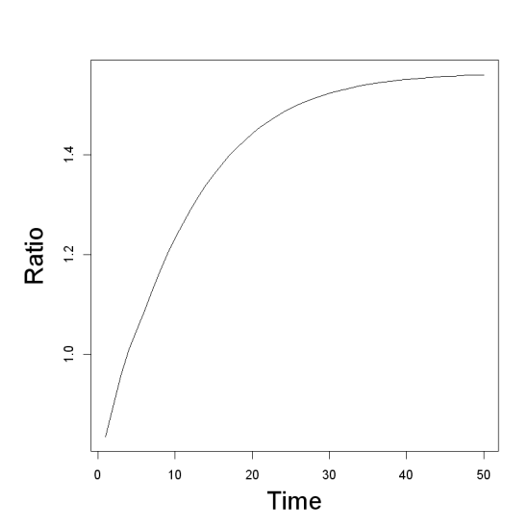

*7. Can symmetrical dispersal (gb = bg > 0) induce such a change in ‘ratio’? Try dispersal probabilities of 0, 0.05, 0.1, 0.15, and 0.2 (by simply changing the parameter values at the top of the code in piece 3, and re-running the code in piece 3); remember to keep gb = bg.*

By changing progressively gb and bg to the same increasing value, the abundance in G relative to B actually decreases. Thus, it is clear that symmetrical adult dispersal cannot explain the currently large relative abundance of the Good colony.

|  |  |  |  |  |  |
| --- | --- | --- | --- | --- | --- |
| gb = bg | 0.00 | 0.05 | 0.10 | 0.15 | 0.20 |
| ratio | 1.56 | 1.18 | 1.06 | 1 | 0.96 |

*8. Approximate, by successive change in bg, the level of adult dispersal from B to G (bg > 0) that can lead to ratio = 4.17 with no adult dispersal from G to B (gb=0).*

Here are the results from a few changes in bg:

|  |  |  |  |  |  |  |
| --- | --- | --- | --- | --- | --- | --- |
| bg | 0 | 0.1 | 0.13 | 0.14 | 0.135 | 0.134 |
| ratio | 1.56 | 3.50 | 4.09 | 4.29 | 4.19 | 4.176 |

*9. Interestingly, black-headed gull colonies move after reproductive failure. Comment on this trait in relation to the previous result.*

As long as there are differences in reproductive values and limited dispersal costs (cf the “Ideal Free Distribution”), there will be selective pressures for individual behaviours that enhance their reproductive value. The key here is that a Bad location tends to remain Bad, and a Good location tends to remain Good. Given this condition (= positive autocorrelation over time of breeding success), if an individual is in a Bad site, even moving at random is favored because of the chance of ending up in a better site.

## Solutions to Exercise 8: Chamois in random environments

*1. Assuming a constant, deterministic environment and the provided estimates of the demographic parameters, is this population viable?*

The asymptotic growth rate is high (λ = 1.16) indicating the population is viable in a constant environment.

*2. What happens when senescence is ignored (i.e., when survival from age 11 onwards is assumed to be the same as the previous age class)?*

s11 <- 0.962

Neglecting senescence (a common feature of ungulate populations) implies that we assume s11+ = 0.962, which changes the asymptotic growth rate to 1.18. This is not a large change and at first seems like a contradiction to the important role survival play in the population dynamics of long-lived species. For example, we only observed  = 0.02 for  = 0.229, leading thus to = 0.08 and = 0.08*0.733/1.16 = 0.05. The paradox is simply that there are few females left in this age class (7.56 %) with a low reproductive value, so they contribute little to the population growth rate and have a small sensitivity. The exact sensitivity and elasticities are 0.0470 and 0.0296, respectively. They differ from the finite increment approximations because of the nonlinearity of  wrt this parameter. The reproductive values in absence and presence of senescence show very different patterns. In the absence of senescence, the reproductive value remains constant with age, because the age of a female does not influence the number of future reproductions expected. When there is senescence, the reproductive value decreases when females approach senescence, i.e. before age at senescence.

*3. Using s*11+ = 0.733, *which demographic parameters have the strongest impact on the deterministic population growth rate?*

The full sensitivity results are:

|  |  |  |
| --- | --- | --- |
| Parameter | Sensitivity | Elasticity |
| m2 | 0.044 | 0.025 |
| m | 0.188 | 0.149 |
| f | 0.405 | 0.174 |
| s0 | 0.307 | 0.174 |
| s1 | 0.226 | 0.174 |
| s210 | 0.752 | 0.622 |
| s11 | 0.047 | 0.03 |

The three “immature” parameters, f, s0, s1 have the same elasticity, 0.174, which is also elasticity(m2)+elasticity(m), and is equal to 1/T = 1/5.746.

While the “impact” of parameters has to be judged according to what are plausible orders of magnitudes in their variation (as we will explain later), it is clear that the prime age survival s210 has a very high absolute and proportional sensitivity because it pertains to survival of age classes with high numbers and the highest reproductive values.

*4. Qualitatively, what do you think this form of environmental stochasticity will do to the chamois population, and which estimator should you use for measuring the population growth rate in a variable environment?*

The population growth rate is likely to be lower than the deterministic growth, to an extent that can be determined only by simulation or though approximation of the ‘stochastic growth rate’.

*5. Using a pseudo-extinction threshold of 100 individuals (when demographic stochasticity can begin to have important effects on population dynamics as we will discuss later), discuss the viability and rate of population growth of the chamois population based on 500 simulations over 100 years, and then over 1000 years.*

The stochastic growth rate estimates over 100 and 1000 time steps (and 500 replicates) are approximately 1.106 and 1.105, respectively (answers may vary among people given these time horizons). The corresponding probabilities of pseudo-extinction were 0 and 0.002. Despite their strong impact on survival, these infrequent catastrophic years do not threaten the long-term viability of the chamois population.

## Solutions to Exercise 9: The Ricker model of density dependence

*1. Using the first part of the code in Ex9Ricker.r, manually change the value of K (the parameter for density dependence) to explore its effect on the resulting population dynamics. Each time you change K, re-run the modeling code as well as that for the plot.*

*K* is often called the carrying capacity for a population. For low to moderate values of *r*, *K* determines the equilibrium value of abundance where birth and death rates balance each other. By changing *K*, the equilibrium abundance changes as shown in the example plot below.

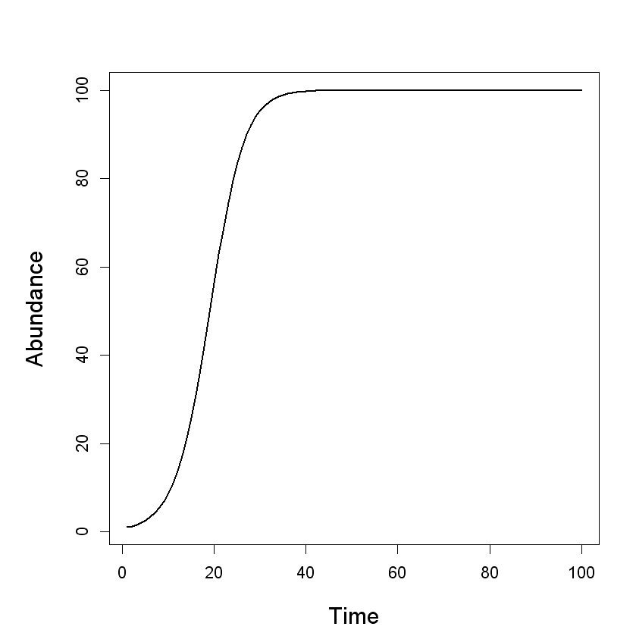

*2. Keeping K fixed at 100, now explore the effects of progressively increasing values of r. Start from r = 1.7 and increase it by 0.2 each time you re-run the code. What happens when r > 2?*

At first we observe damped cycles that stabilize, then perpetual cycles that do not disappear, then cycles with two different types of peaks and troughs (a 4-cycle), and eventually the cycles become erratic where the values of abundance at the peaks and troughs never repeat themselves, which is called “chaos” (shown below in the example plot with r=2.9t). For structured populations, chaotic dynamics can form beautiful “Fractals” (*sensu* Benoit Mandelbrot).

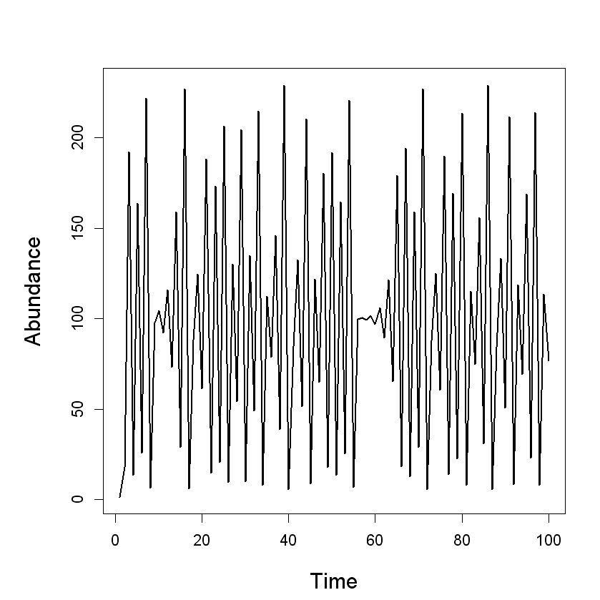

*3. … Using the second part of the code, build a bifurcation diagram for the Ricker model and discuss it as r increases.*

The resulting bifurcation diagram below shows the transitions from stability to cycles to chaos as *r* increases (note the stability ‘bifurcates’). Around *r* ≈ 2.78, chaos starts to occur.

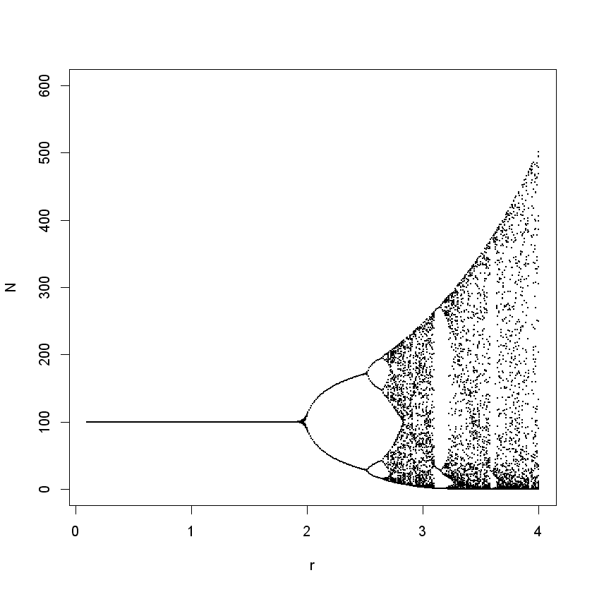

*4. … Examine the metapopulation matrix model and see if you can interpret the meaning of each transition.*

The density-dependent metapopulation model is a 2-by-2 matrix model. The (Ricker) density-dependent population dynamics of the source population is summarized in the upper left term multiplied by the probability of individuals staying in the source location. The lower left term represents the production of individuals in the source population multiplied by the probability they ‘disperse’ to the sink (some individuals must disperse because the source habitat fills up and reaches its carrying capacity). In the bottom right term, the demography in the sink population is summarized by a simple survival probability. There is no local production in the sink, it all comes from the source. A non-zero equilibrium abundance of individuals can nevertheless exist in the sink because of the continual flow of individuals from the source (as shown in the plot that can be produced with the provided code). The upper right of the matrix contains a 0, indicating no dispersal from the sink to the source.

*5. Using the provided code, obtain a bifurcation diagram for the sink population within the metapopulation.*

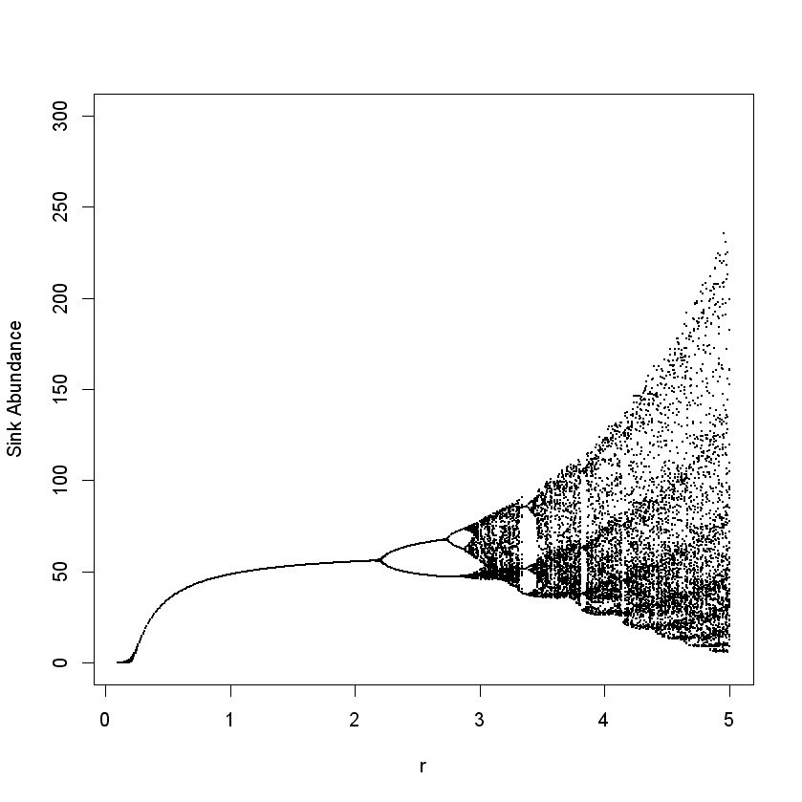 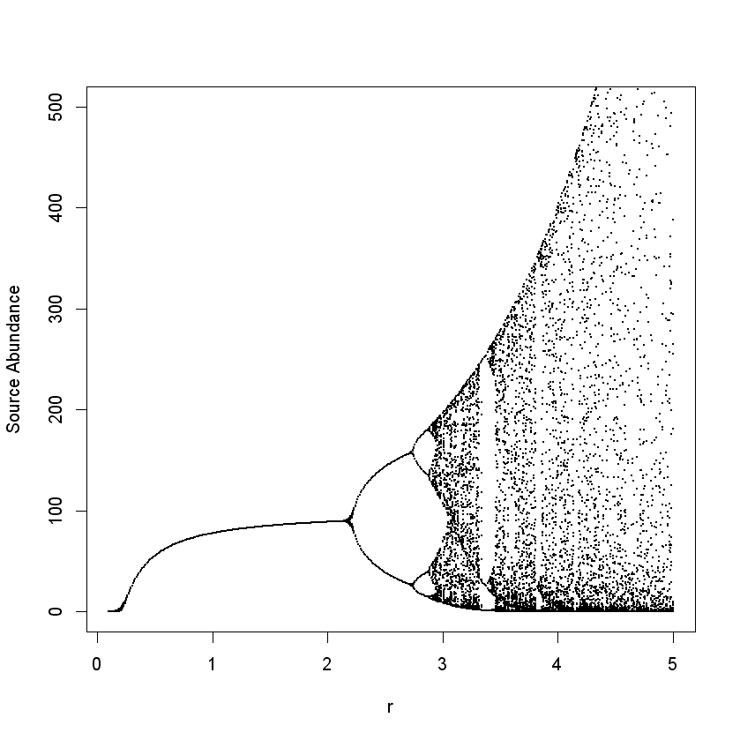

## Solutions to Exercise 10: Demographic stochasticity in the house sparrow

*1. … Examine the first piece of code to get a feel for how the scalar recurrence equation for house sparrow demography is implemented with demographic stochasticity. Run the first piece of code (including that for the plot) a few times to visualize the random impact of demographic stochasticity (coin flipping) on the dynamics of a small population.*

Demographic stochasticity is implemented in the code using Poisson and binomial distributions for the demographic outcomes of N individuals experiencing the expected value of a given vital rate. We can see that there are few individuals (low N enforced by the DD), the outcomes are quite random and different across simulations (and thus quite different from what your neighbour is seeing on their computer).

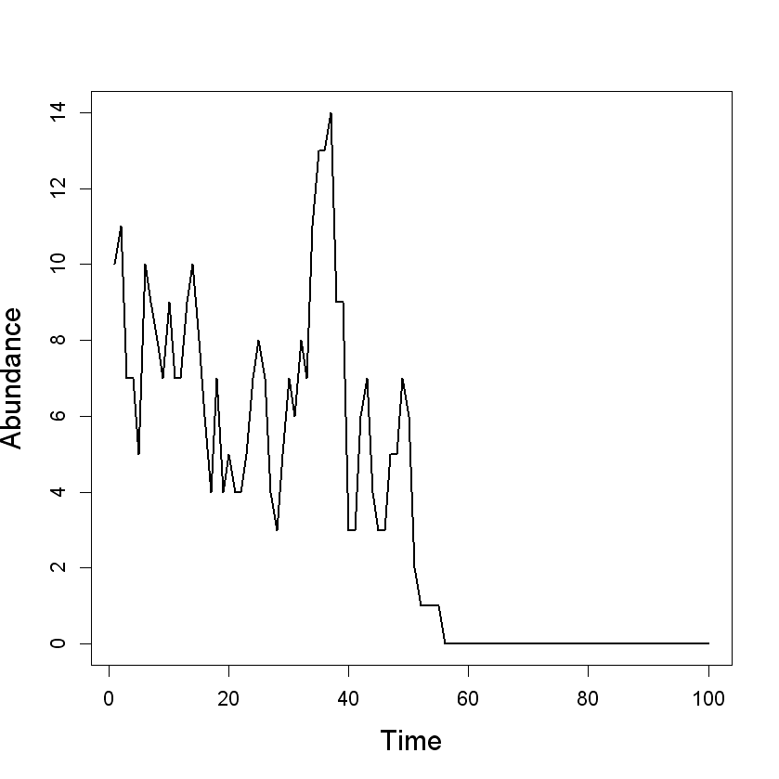

*2. Obtain a formula for the deterministic equilibrium of the house sparrow model in the absence of demographic stochasticity, but in the presence of density dependence (N*).*

To attain the solution we start with , then replace all values of N with N*, the equilibrium abundance, . We then solve for N* . Note that .

*3. The population size conditional on non-extinction is distributed as the “Quasi-Stationary Distribution”, and the stochastic equilibrium mean is denoted as lim E(Nt+1/ Nt >0). Part two of the code has lines of code to estimate moments (e.g., the mean) of the Quasi-Stationary Distribution, extinction probabilities, and extinction times (also conditional on E[N] > 0) across 10,000 simulations. Inspect and then run part two of the code to attain estimates of each of these ‘population viability’ parameters over 100, 200, 300, and 400 years.*

Because of the use of loops, the code takes quite a while to run. The loops explicitly show you the demographic and probabilistic process but there are ways to not depend on loops and significantly speed up the computation. Below are the results from R.

sumtable

[,1] [,2] [,3]

[1,] 0.8716 39.54234 9.85493

[2,] 0.9890 51.09909 10.63333

[3,] 0.9987 51.98488 12.33333

[4,] 1.0000 53.16040 NaN

*4. Using what you have learned above, and the third piece of code, complete rows 1-4 in the table below by manually changing the vital rate values to those specified in the table. Each time you change a vital rate, re-run the entire third piece of code (it takes time to run).*

|  |  |  |  |  |  |
| --- | --- | --- | --- | --- | --- |
| s0,low | s1,low | λmax | Deterministic equilibrium N* | Cumulative Pr(extinction) over 1000 time steps | Stochastic equilib. lim E(Nt+1 / Nt>0) |
| 0.20 | 0.50 | 1.1 | 9.53 | 1 | Not defined |
| 0.25 | 0.50 | 1.25 | 22.31 | 0.5152 | 19.9 |
| 0.30 | 0.50 | 1.4 | 33.65 | 0.0028 | 32.2 |
| 0.30 | 0.60 | 1.5 | 40.55 | 0.0002 | 39.3 |
| *Beta*(18.5,55.5) | 0.50 | 1.25 | 22.31 | 0.7582 | 19.3 |

*5. Given an infinite time horizon, what would be the overall probability of extinction in each scenario above? For the mathematically inclined: Why is the stochastic equilibrium smaller than the deterministic equilibrium?*

Given an infinite time horizon, the overall probability of extinction is always = 1; all populations will eventually go extinct. However, the probability of extinction over a finite time horizon does vary markedly, as does its complement, the probability of reaching the quasi-stationary distribution.

For the math-stat fans, the stochastic equation is , which implies. When  is distributed as the QSD and  is the probability of extinction in one time step, then ; the population goes extinct with probability  or transitions to a new population size distributed according the QSD with probability . By Jensen’s inequality, the convexity of the model function  in the domain considered is such that , and hence . This implies that  because the variance of the QSD makes the effect of the convexity much larger than that of . Then which finally implies for the QSD mean that .

*6. Given the effect of λmax on the risk of extinction over a finite time horizon, what do you think about the concept called the “extinction vortex”?*

From the table above, the shift in extinction probabilities over a finite time horizon is very sharp with the change in λmax, and nearly creates a sharp borderline between populations rapidly doomed to extinction and those for which the probability of extinction is very small or even negligible, so the vortex may largely result from the fact that a population is on one side or the other of the borderline. This result does not imply that other factors contributing to accelerated extinction in small populations (e.g., Allee effects) should be neglected.

*7. What happens when s0,low is additionally subject to random environmental variation? Keep s1,low at 0.5 and replace the numerical value for s0,low in the R code with “rbeta(1,18.5,55.5)”, which specifies a Beta distribution for the environmental stochasticity in s0,low with a mean of 0.25 and variance of 0.0025. Then re-run part three of the code and complete row 5 of the table in problem 4 (note: you just need to un-comment a line of code within the time loop and comment out the original line for s0,low).*

The population abundance varies quite a bit, and the risk of extinction over 1000 years increases notably (shown in the last line of the Table for problem 4 above). Because of the larger variance of population size, the average number of individuals in the QSD is even smaller than in the absence of random environmental variation. The combined effects of environmental and demographic stochasticity on population viability can be biologically significant for small populations of conservation concern.

## Solutions to Exercise 11: The plight of the polar bear

**A. Basic exploration…. Perform basic matrix model calculations and provide the following information (and answer the questions) (Part I of the code):**

1. *What are the annual population growth rates? When did the polar bear population grew at the highest and the lowest rates? Plot the population growth rates for each year of the study.*

Population growth rate was highest and lowest in the year 2002 and 2004, respectively.

> year

[1] 2001 2002 2003 2004 2005

> growth.rates #Table 1, Hunter et al

[1] 1.0590883 1.0614439 1.0362673 0.7649747 0.7991206

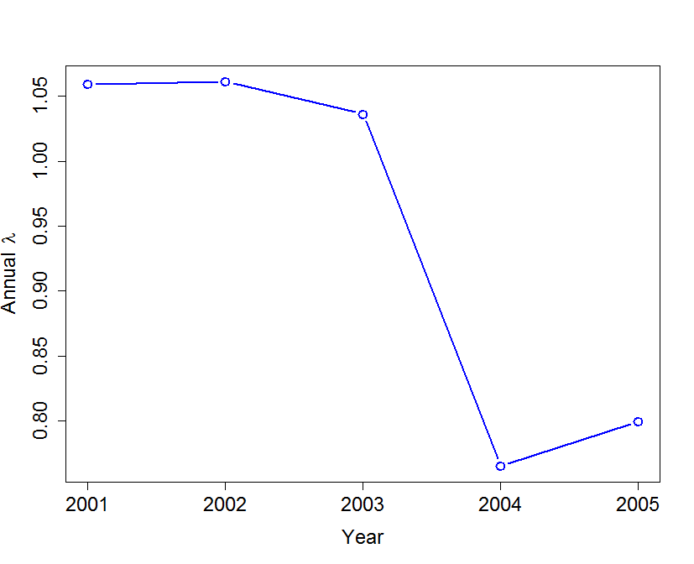

1. *Calculate year-to-year differences in population growth rates, and plot the results. When did the largest change in λ occur?*

The largest year-to-year change occurred during 2003-2004, with a drop in λ of 0.27.

> c('2001-2002', '2002-2003', '2003-2004', '2004-2005')

[1] "2001-2002" "2002-2003" "2003-2004" "2004-2005"

> growth_diff

[1] 0.002355608 -0.025176604 -0.271292607 0.034145924

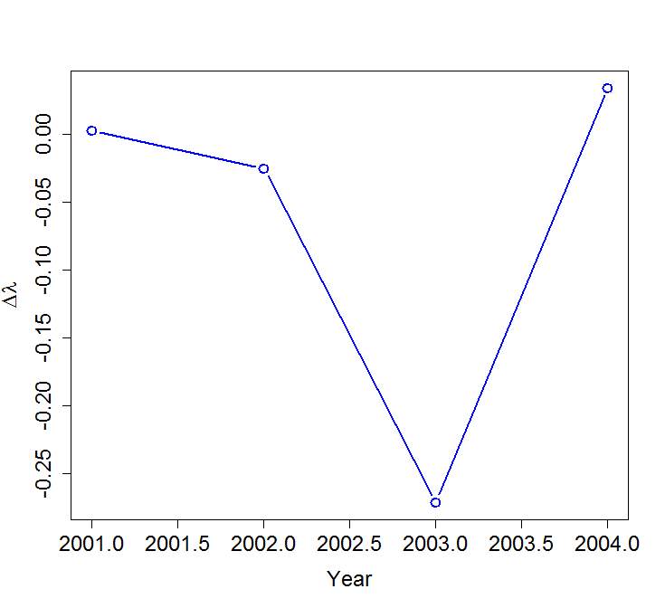

1. *Calculate the mean, standard deviation, and range of λ across years. What conclusions can you draw based on these results?*

> mean(growth.rates)

[1] 0.9441789

> sd(growth.rates)

[1] 0.1488217

> min(growth.rates)

[1] 0.7649747

> max(growth.rates)

[1] 1.061444

The polar bear population experienced an overall decline during this study. However, the growth rate was highly variable (ranging from 24% annual decline to 6% annual increase). The overall decline in the population, as well as the high variability in the growth rate indicate that the long-term persistence of the population is questionable.

***B. Stochastic demography: estimating long-term growth rate of the polar bear population in a stochastic environment (Part Ib of the code)***

1. *Calculate stochastic growth rate (Tulja’s approximation, as well as simulations + CI) assuming that (use maxt ≥10000):* 
   1. *Each year (i. e., matrix) occurs with equal probability*

If we assume each year occurs with equal probability, then we have

> prob = rep(1/len, len) #Assume each year occurs with equal probability. The IID assumption

> prob

[1] 0.2 0.2 0.2 0.2 0.2

The *popbio* function *stoch.growth.rate* calculates the stochastic growth rate using both methods:

> stoch.results$approx #Tulja's approximation log Lambda s

[1] -0.07419928

> stoch.results$sim #...based on simulation

[1] -0.07023522

> stoch.results$sim.CI #...CIbased on simulation

[1] -0.07299264 -0.06747779

* 1. *The first two years of the study occurs more frequently than other years, with prob =c(.4, .3, .1, .1, .1). What conclusions can you draw from these results?*

By simply repeating the above analyses with prob =c(.4, .3, .1, .1, .1), we find the following results:

> prob =c(.4, .3, .1, .1, .1)

> prob

[1] 0.4 0.3 0.1 0.1 0.1

> stoch.results = stoch.growth.rate(matrices = polar.bear.matrices, prob = prob, maxt = 10000)

[1] Calculating stochastic growth at time 1

[1] Calculating stochastic growth at time 10000

> stoch.results$approx #Tulja's approximation log Lambda s

[1] -0.008311729

> stoch.results$sim #...based on simulation

[1] -0.006899743

> stoch.results$sim.CI #...CIbased on simulation

[1] -0.009225722 -0.004573764

If the vital rates associated with the year 2001 and 2002 were to occur more frequently, the population would become almost stable (or only slightly declining). This makes sense because the polar bear population was increasing during those two years.

> growth.rates

[1] 1.0590883 1.0614439 1.0362673 0.7649747 0.7991206

**C. Understanding year-to-year changes in λ: Fixed effect LTRE analysis (Part II of the code)**

1. *Perform 1-way LTRE analysis, comparing population projection matrix for each year with that in the previous year. Examine the relevant results. How good was your LTRE model? How do you know?*

> year[2:len]

[1] 2002 2003 2004 2005

> observed_lambda

[1] 1.0590883 1.0614439 1.0362673 0.7649747 0.7991206

> lambda_pred

[1] NA 1.0614420 1.0362083 0.7624817 0.7993991

Excellent fit of the model, because observed and LTRE-predicted values of λ were almost identical!

1. *The biggest change in λ occurred during 2003 - 2004, a drop of 0.27! So, let’s just focus on understanding what caused that decline.* 
   1. *Which entry of the projection matrix made the largest contribution to this decline? How do you know?*
   2. *Was this decline because of big change in the value or due perhaps to some other reasons? You will have to examine matrix of differences, contribution matrix and perhaps the sensitivity matrix (of the mean matrix) to answer this question.*

Matrix of entry-wise differences:

> diff_matrix[[3]]

[,1] [,2] [,3] [,4] [,5] [,6]

[1,] 0.0000 0.0000 0.0000 0.0000 0.0000 -0.2606

[2,] -0.2837 0.0000 0.0000 0.0000 0.0000 0.0000

[3,] 0.0000 -0.2837 0.0000 0.0000 0.0000 0.0000

[4,] 0.0000 0.0000 -0.2837 0.2527 0.1162 -0.2075

[5,] 0.0000 0.0000 0.0000 -0.4602 -0.1057 0.0000

[6,] 0.0000 0.0000 0.0000 0.0000 -0.2471 0.0000

Sensitivity matrix evaluated at the mean values:

> sen_mean

[,1] [,2] [,3] [,4] [,5] [,6]

[1,] 0.01350670 0.01173840 0.01020161 0.4875001 0.09389176 0.03562633

[2,] 0.01554137 0.01350670 0.01173840 0.5609381 0.10803579 0.04099315

[3,] 0.01788255 0.01554137 0.01350670 0.6454389 0.12431051 0.04716843

[4,] 0.02057642 0.01788255 0.01554137 0.7426690 0.14303689 0.05427398

[5,] 0.02150465 0.01868926 0.01624247 0.7761719 0.14948950 0.05672236

[6,] 0.02552297 0.02218151 0.01927751 0.9212061 0.17742285 0.06732140

Contribution matrix:

> cont_matrix[[3]]

[,1] [,2] [,3] [,4] [,5] [,6]

[1,] 0.00000000 0.00000000 0.00000000 0.0000000 0.00000000 -0.02104092

[2,] -0.01167572 0.00000000 0.00000000 0.0000000 0.00000000 0.00000000

[3,] 0.00000000 -0.01167572 0.00000000 0.0000000 0.00000000 0.00000000

[4,] 0.00000000 0.00000000 -0.01167572 0.1175190 0.03014253 -0.02357405

[5,] 0.00000000 0.00000000 0.00000000 -0.2299327 -0.02945778 0.00000000

[6,] 0.00000000 0.00000000 0.00000000 0.0000000 -0.08241446 0.00000000

> growth.rates[4] - growth.rates[3]

[1] -0.2712926

> #Sum of LTRE contribution for the same 2 yrs

> sum(cont_matrix[[3]])

[1] -0.2737856

The LTRE model almost perfectly predicted the decline in λ from 2003 to 2004.

## Solutions to Exercise 12: A simple integrated population model

1. *Run the R-program provided for the statistical study of this basic IPM with successive observed population sizes {100, 110, 120, 135, 148, 160, 175, 188, 200}, and independent demographic parameter estimates $\hat{s}$ = 0.8200 (s.e. = 0.0040) and $\hat{f}$ = 0.2500 (s.e. = 0.0050).*

One obtains ${\hat{λ}}_{C}$ = 1.0854 and ${\hat{σ}}^{2}$ = 6.2082 (i.e. $\hat{σ}$ = 2.4916). In turn, s.e.(${\hat{λ}}_{C}$) = 0.0061. Obviously, based on the demographic information, one gets ${\hat{λ}}_{D}= \hat{s}+\hat{f}$ = 0.8200+0.2500 =1.0700, with s.e. $\sqrt{{\hat{σ}}_{f}^{2}+{\hat{σ}}_{s}^{2}}$ = 0.0064, as the two demographic estimates are independent.

The minimum variance combined estimate is equivalent to a ML estimate under assumptions of normality for $Y_{t}$, $f$, and $s$. It value is $\hat{λ}$ = 1.0781 with s.e. equal to 0.0044.

The estimates of f and s are revised through the integration process to $\tilde{f}$ and $\tilde{s}$ equal to 0.2549 and 0.8232, respectively. Further calculations would provide estimates of their s.e.

1. *Compare statistically the estimated $λ$ values from counts and demographic parameter estimates, respectively. Are these two estimates of $λ$ compatible? Are they compatible if $f$ equals 0.20 (with the same s.e.)?*

The standardized difference between the two estimates is distributed under the null hypothesis of coherence between the two types of information as a random variable N(0,1). It value, ${z=(1.0854-1.0700)}/{\sqrt{{0.0061}^{2}+{0.0064}^{2}}}$ = 1.74, appears thus as non-significant (at the 0.05 level), and one can conclude the two estimates of $λ$ are compatible. This is no more the case if $f$ equals 0.20 as z= 7.41 is highly significantly different from 0. In the real world such a difference might result for instance from permanent juvenile emigration out of the study area, biasing $f$ downwards, or immigration not represented in the model biasing upwards the growth rate in numbers.

1. *Back to the original demographic estimates, calculate the percentage of decrease in $var(λ)$ from the demographic based estimate to the combined one.*

One goes from 0.0064² = 4.0960e-05 to 0.0044² = 1.9360e-05, corresponding to a 53 % decrease.

1. *How do you explain one can improve the estimation of $f$ and $s$ in the IPM while they are not separately estimable based on counts only?*

The counts contain some information on survival and net fecundity, even if the two components cannot be separated. For instance, if counts indicated a growth rate significantly below 0.8, the provided demographic estimates of $s$ would be untenable.

1. *Propose a value of the standard error of $f$ to mimic a situation where $f$ is not estimable. Then obtain and discuss the estimates of $λ$ when $f$ is not estimable.*

An infinite variance indicates a non-identifiable parameter. in practice a large s.e. for $\hat{f}$, such as 1000, will be adequate for mimicking this situation. When running the program with such a value, the combined estimate $\hat{λ}$ remains equal to ${\hat{λ}}_{C}$, with the same s.e.. Thus, the demography does not bring any information on growth rate. In turn, the combined estimate $\tilde{s}$ of s remains equal to $\hat{s}$ =0.82 and that of $λ$, $\hat{λ}$, remains equal to ${\hat{λ}}_{C}$ = 1.0854. The integration produces then an estimate of f, $\tilde{f}={\hat{λ}}_{C}-\hat{s}$ = 1.0854-0.8200 = 0.2654. We see here one of the major potential of IPMs, which is to produce estimates of parameters not directly estimated, filling thus a gap.

1. *Coming back to the original estimates of $f$ and $s$ and their s.e., check what happens with observed population sizes 10 times as big as the original ones. Comment.*

Both ${\hat{λ}}_{C}$ and ${\hat{σ}}^{2}$ remain unchanged, due to the multiplicative nature of the growth rate, that wipes out the scaling effect. As a consequence, the results are the same as those based on the original data.

## Solutions to Exercise 13a: Exploitation in a matrix model with two sexes

1. *After carefully examining the file Ex_13a_Deer.r, describe the main demographic traits of this hypothetical red deer population that is based on the many studies of this charismatic species*

* 2 yr old females have a lower fecundity than older females (parameter a2), likely because not all 2 yr olds breed.
* Prime age males (until age 8) have a natural survival probability (q) that is higher than that of older males (d).
* The model population has an uneven sex-ratio at birth (parameter sr, 60% of females at birth), further made more unbalanced in favour of females by the lower survival (+ harvesting) of males.
* The ratio reproductive males /reproductive females is based on males aged 4 or more and females aged 2 or more. Although sexually mature at an earlier age, it takes time for a bull to gain the stature needed to eventually compete for females.
* The probability of reproduction p is modelled as a logistic (monotonic) function of this ratio, with an arbitrary parameter b that could be estimate from field data.

*2. Using the code in Ex_13a_Deer.r, use the two-sex matrix model for red deer and plot the relationship between male harvest rate and asymptotic population growth rate. Inspect the vector of harvest rates analyzed, and the resulting population growth rates, to find the harvest rate that lead to a stationary population. Denoting λ0 as the asymptotic growth rate when h = 0, also calculate and plot λ0(1-h), which is the population growth rate assuming completely additive effects of the loss of males through harvest on the population growth rate. Comparing your two plots, what can you say about the degree of compensation in the harvest of male red deer at the population level?*

The growth rate  decreases much less rapidly than λ0(1-h), as shown by the figure at right, i.e; the harvest of males in such a polygynous species is highly compensatory at the population level. This would not be the case for harvest of females. When inspecting the vectors of examined harvest rates and corresponding population growth rates, the male harvest rate that leads to a stationary population is 0.23 , which can roughly be seen in the plot below.

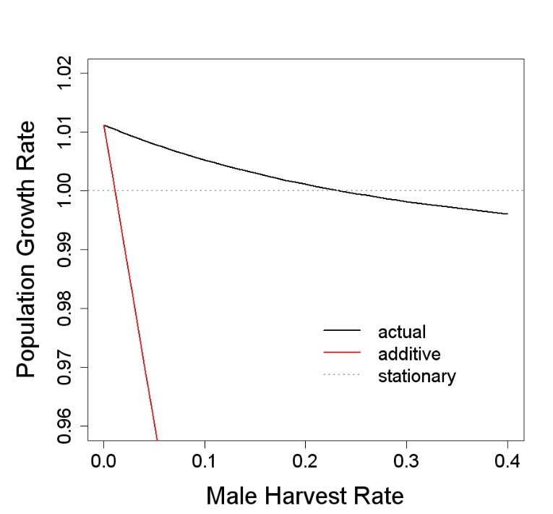

## Solution to Exercise 13b: Management of Overabundant Cormorant

*1. Using the density-independent matrix model for cormorants in the Ex_13b_Cormorant.r file that is parameterized with the demographic parameters described above (as well as others described in the file), does an annual rate of growth of 15% per year seem plausible?*

The demographic parameters and density-independent matrix model lead to a growth rate of 1.187, equal to 18.7 % growth per year, quite compatible with those estimated from winter surveys of abundance (15 %). This result confirms what are surprisingly high rates of population growth for such a large bird, but nevertheless possible given the combination of high survival and high fecundity. The high fecundity is thought to be associated to the fish diet that makes it possible to raise a large brood of large chicks that survive well.

*2. To limit the increase in numbers, a manager might be quite interested in knowing if it would be more efficient to remove eggs from nests or cull individuals capable of flight. By lowering the cs and cf variables, one at a time (e.g., changing each one from 1 to 0.9), which type of management action would lead to the largest reduction in population growth rate given equivalent percentage changes in clutch size vs. survival? What is the general rule explaining your findings?*

Taking the baseline scenario as a starting point, removing 10 % of the eggs (cf = 0.9) leads to an annual growth rate of 1.1705. The decrease in λ is 1.43 % (from 1.187 to 1.170). The ratio of the relative change in growth rate to the relative change in fecundity is thus only 0.14. In a similar fashion, removing 10% of individuals capable of flight (changing cf back to 1 and then cs to 0.9 for example) changes the annual growth rate from 1.187 to 1.069, a relative change in λ exactly equal to 10%.

As discussed before, we know this result is linked to generation time T, equal to 7.17 years in the baseline scenario. Its inverse, 0.14 is the elasticity of λ to a change in fecundity, while the elasticity to a change in survival (of all age classes) is 1; thus the 1:1 relationship between a percentage change in survival and the percentage response in λ.

It is not surprising that similar results were obtained by Bédard et al. (Colonial Waterbirds, 1995) in Canada for the double-crested cormorant *Phalacrocorax auritus*.

The intuitive explanation is that removing an egg or chick is not equivalent to removing an adult because few ‘eggs’ actually result in breeding adults. By removing birds capable of flight, including breeding adults, one removes their ‘remaining lifetime production of offspring’. The effect of culling is thus stronger than egg removal.

*3. The assumption of exponential growth is strong and will not be relevant in the long-term. There is no doubt that regulation through a density-dependent reduction of fertility or survival should eventually occur. Indeed, such a regulation may have already been present in Northern Europe after the year 2000. In order to model a density-dependent process, we can multiply nestling survival (commonly limited by per capita food availability) by a function that decreases exponentially as a function of the number of breeding females. By looping through alternative values of the density-dependent coefficient for nestling survival B, use the second piece of code in Ex_13b_Cormorant.r to find the value of B that would lead to an equilibrium number of breeding females (nbc) equal to 20,000.*

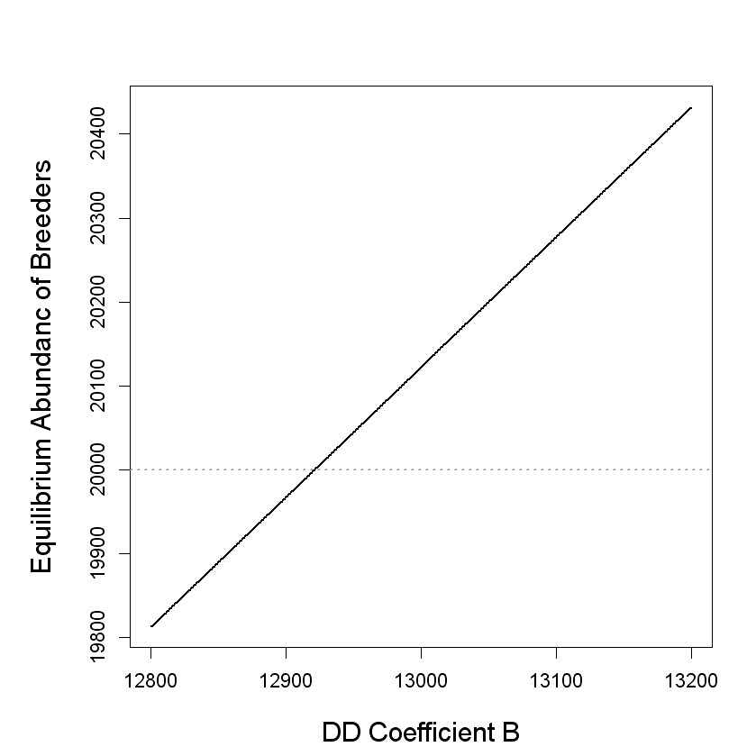

Using the graph, we can look more closely at the simulate values of B, the density-dependent coefficient affecting nestling survival, to see which value confers an equilibrium abundance of breeding females = 20,000.

eqnbc[100:200]

Bseq[122]

B = 12921 leads to nbc = 20,000

*4. In the density-dependent environment, estimate the percentage reduction in fecundity or survival required to decrease the equilibrium population size by approximately 20 % (i.e., ~20,000×0.8; use the value of B that resulted in your answer for problem 3 above).*

The higher elasticity to the cull of individuals capable of flight is again confirmed in the density-dependent environment. A drop of survival by only 2.5 % (cs=0.975) is sufficient to bring the equilibrium number of breeders to 16,226, close to a 20 % decrease (which would be an equilibrium abundance of 16,000), while it takes the removal of 25% of the eggs (cf = 0.75) to reach a similar level (16,223).

This density-dependent model is a bit arbitrary. Models with density-dependence in survival should show a stronger compensation of the management actions than does this one, precisely because of the higher elasticity to survival.

## Solution to Exercise 14: Whooping crane PVA

* + - 1. Just run the code already provided: r_mean = 0.0327374; r_sd = 0.06861572. These results indicate that this is a rapidly increasing population, but there is substantial temporal variability in the population growth process.
      2. Just run the code already provided. The probability of quasi-extinction is 0; since none of the simulated population trajectories fell below the critical threshold, the time to extinction parameters cannot estimated. These results, along with the estimates of population growth rate suggest that the population is unlikely to face extinction risk in the near future provided that the underlying model assumptions hold.
      3. Just change the parameter values (already given) and re-run the code.

1. Calculate and report the probability of quasi-extinction, and median time. See note below regarding the interpretation of PVA results

>

> prob.extinction

[1] 0.772

> mean.time.extinction

[1] 185.9003

> median.time.extinction

[1] 187

b. Plots:

1. See below (PVA steps revisited).
   * + 1. On your own.

**PVA steps revisited**

Now that we have some experience conducting PVA, let’s briefly revisit the PVA steps discussed in the lecture:

1. ***Identification of objectives/questions*:** Like all good modeling exercises, PVAs must be guided by clearly defined objectives or questions. Analyses will help you address the questions but only you – as a biologist or a manager – can come up with questions that necessitate you to perform a PVA in the first place.
2. ***Selection of models and model structure*:** Because we only had count (time series of abundance) data, we had limited choices. We considered stochastic exponential growth model using simulations, and stochastic differential equation model (SDE; also, a form of the stochastic exponential growth model). Because there was little or no evidence for density-dependence with the datasets we worked with, we did not explore the stochastic logistic growth model. However, we strongly encourage you (especially, graduate students) to explore that option – you have the necessary theoretical background and tools to do so.
3. ***Estimating parameters:*** For the stochastic exponential model, we estimated mean and variance of the population growth rate. For the SDE, we estimated process mean μ and process variance σ2 using the best available method.
4. ***Running the model:*** We ran the models using R; we wrote some functions/scripts ourselves but also used some functions available in *popbio*.
5. ***Sensitivity analysis, scenario planning:*** We did not do the sensitivity analysis. We could have used a simulation approach to examine how the probability of (quasi)extinction changes in response to small (proportional) change in the model parameters (as well as starting and critical population sizes).If we were performing the PVA to make management recommendations or for a publication, we would have to conduct sensitivity analysis. We encourage you to explore this as well.
6. ***Evaluation of results and assumptions:***  We practiced caution when interpreting the results, recognizing the distinction between the probability of ultimate (quasi)extinction vs. the probability of (quasi)extinction within a certain timeframe. We also learned how to interpret time to extinction **conditional** on the probability of (quasi)extinction.

When interpreting and writing-up the results, always be mindful of model limitations. We used a very simple model that ignored many things we know can influence population dynamics and persistence, including age or stage structure, density-dependence and so on. Recognize the model and data limitations, and avoid making sweeping conclusions based on results of a fairly simple analysis.

## Solution to Exercise 15: Polar bear PVA

1. Assuming that the environment observed during each year of the study occurs with equal probability (call it *p_eq* scenario):
   1. Calculate and interpret the stochastic growth rate;

> stoch.growth.rate(

+ matrices = p.bear.mats, prob = p_eq, maxt = 50000, verbose = FALSE

+ )

$approx

[1] -0.07419928

$sim

[1] -0.07205026

$sim.CI

[1] -0.07328978 -0.07081074

* 1. Project the population size for 50 years, and plot the ending population size. Interpret the results.

> t_max = 50

> reps = 1000

> #Assuming p_eq

> nt.eq = stoch.projection(

+ matrices = p.bear.mats, n0 = n0, tmax = t_max, nreps = reps, prob = p_eq

+ )

>

> #Let's calculate total population size for the last year of each simulation

>

> N.eq = rowSums(nt.eq)

> sum(N.eq)

[1] 67679.27

>

> #Plot the distribution of ending population size

> hist(

+ N.eq, col = "red",

+ breaks = seq(0,5000, 100), xlim = c(0,1500), xlab = "Final population size at t = 50",

+ main = 'Assume: p_eq', cex = 1.5, cex.main = 1.5, cex.lab = 1.5, lwd = 1.5,

+ cex.axis = 1.5

+ )

> abline(v = sum(n0), lty = 3) # Reference line - starting population size

1. Perform PVA under the *p_eq* scenario. Report and thoroughly interpret all relevant results, including the probability that the population will go quasi extinct within the next 20, 30, 40 and 50 years. Report all relevant plots, summary statistics etc.
   1. What do you conclude regarding the dynamics and persistence of the polar bear population?

> Nx = round(sum(n0)*.10) #Critical threshold: 10% of the original size

> nreps = 1000

> maxruns = 10

> #Quasi-extinction probability under the assumption of p_eq

> extCDF.p_eq = stoch.quasi.ext(p.bear.mats, n0, Nx=Nx, nreps=nreps, maxruns = maxruns, prob = p_eq, sumweight=c(0,1,1,1,1,1))

Calculating extinction probability for run 1

Calculating extinction probability for run 2

Calculating extinction probability for run 3

Calculating extinction probability for run 4

Calculating extinction probability for run 5

Calculating extinction probability for run 6

Calculating extinction probability for run 7

Calculating extinction probability for run 8

Calculating extinction probability for run 9

Calculating extinction probability for run 10

> mean_extCDF = rowMeans(extCDF.p_eq)

> mean_extCDF[20]

[1] 0.1313

> mean_extCDF[30]

[1] 0.4893

> mean_extCDF[40]

[1] 0.7834

> mean_extCDF[50]

[1] 0.9222

Now you are a PVA expert so we leave the interpretation to you!

* 1. Knowing what you know about the global climate change and its impact on the polar environment, what would be your recommendations for the management of polar bear population to ensure its long-term persistence? Again, provide supporting evidence and justify your answer.

On your own. Be creative, perform additional analyses as necessary to answer this question.

1. Repeat analyses in 2-3 above, assuming that
   1. Poor ice conditions occur 50% of the time;
   2. Poor ice conditions occur 60% of the time;
   3. Answer questions in exercises 1-2 under these assumptions. What are your overall conclusions?

Here’s how you would calculate the environmental probability vector for each scenario:

> #Poor ice conditions occur 50% of the time;

> q = 0.5

> p_uneq1 = c((1-q)/3, (1-q)/3, (1-q)/3, q/2, q/2)

>

> #Poor ice conditions occur 60% of the time;

> q = 0.6

> p_uneq2 = c((1-q)/3, (1-q)/3, (1-q)/3, q/2, q/2)

Just change the environmental probability vector *p*, and run the analyses as above. As a PVA expert, you now know how to interpret the results.

1. Based on what you have learned about PVA, can you summarize the steps that are needed to calculate extinction parameters using stochastic matrix models? Write a code to perform the relevant calculations and return the results that are most relevant to your study. That way, you don’t have to rely on what popbio functions can do; you can modify your code to do what you need to do for your particular study.

There is nothing really special about what *popbio* functions do; if you know the concept, you can easily write the functions needed to do the calculations. In fact, we very much encourage you to write our own function– so you won’t be restricted to what *popbio* functions can do. Now that you are an experienced R user, you will find that it is not that hard at all. And if we write our own codes, we can do **exactly** what we want it to do. Here are the (fairly straight-forward) steps:

1. Perform structured stochastic population projection, from time = 1 to *tmax* as discussed above;
2. Each time step, calculate population size. If some stages/age classes are to be excluded for the calculation of total population size, use the *wt* vector for this purpose, and store the population size. Save the results in a matrix of dimensions (*tmax* x *nreps*) – each column of this matrix will be one simulated trajectory;
3. Examine each trajectory, and check to see if population size falls below the threshold or critical population size;
4. If it does not, there’s nothing to be done – the simulated trajectory does not go extinct or quasi-extinct. If it does, do the following:
   1. Increase the extinction counter by one;
   2. Record the point in time when the simulated population trajectory fell below the critical threshold. Record that time (which will be subsequently used to calculate mean or median time to extinction etc.);
   3. Once a trajectory falls below the threshold, consider that trajectory extinct and set it to zero from that point forward. This is really not necessary for the calculations but just so we are logically consistent;
   4. Output extinction counter and a vector of extinction time.
5. If none of the trajectories fall below the threshold, conclude that the population has a zero probability of extinction/quasi-extinction for the given parameters and time frame used.
6. If one or more trajectories do go extinct, calculate:
   1. Probability of quasi-extinction as: (number of trajectories that go extinct)/(number of simulations);
   2. Analyze the extinction time vector as necessary. Note that if the probability of quasi-extinction is zero (i.e., no trajectories go extinct) then the extinction time vector is empty and no further calculations are possible!
7. If you want, you can plot the “updated” trajectories. The only difference is that all trajectories that fall below the critical threshold will be set to zero from thenceforth.

That’s pretty much it! Let’s go ahead and do it so there is no mystery! You will find that this is one of the things that is easier done than said – the long “to-do” list above can be translated into just a few lines of R code.

First, write a function to perform stochastic simulations:

> stoch.projection2 =

+ function (matrices, n0, tmax, nreps, prob, wt) {

+ popsize = matrix(0, nrow = tmax, ncol = nreps)

+ for (i in 1:nreps) {

+ A = sample(matrices, tmax, replace = TRUE, prob = prob)

+ n = n0

+ for (j in 1:tmax) {

+ n = (A[[j]] %*% n) * wt

+ popsize[j,i] = sum(n)

+ }

+ }

+ return(popsize)

+ }

Next, specify input parameter values, run the function and save the trajectories (steps 1 – 2):

> #Input arguments (can also use those defined above)

> tmax = 50; nreps = 1000; prob = p_eq; wt = c(0, 1, 1, 1, 1, 1)

> #Runt he function

> out2 = stoch.projection2(matrices = hudsonia, n0 = n0, tmax = tmax, nreps = nreps, prob = p_eq, wt = wt)

Now, we have the trajectories saved in a matrix *out2*. Each column of this matrix is a simulated population trajectory. Next we examine each trajectory, see if and when population size falls below the critical threshold, and if it does fall below the critical threshold, record the time when that happens (steps 3-4):

> l = nrow(out2)

> N_critical = 20

> ext_count = 0 #start the counter at 0

> time = c() #empty vector to hold time when the population hits the threshold

> out3 = out2

> for (i in 1:ncol(out2)){

+ pos = which(out3[,i] <= N_critical) #Find the point in time when the

+ #the population hits critical threshold

+ if (length(pos) > 0){

+ ext_count = ext_count + 1 #Update the extinction counter

+ min = min(pos)

+ time = append(time,min)

+ out3[min:l,i] = 0 # If the population size falls below critical threshold,

+ # consider it extinct and set it to zero

+ }

+ }

Now, we have everything we need to calculate the probability of quasi-extinction within the simulated timeframe. Let’s implement steps 6-7 above and calculate extinction metrics and plot the relevant results:

> ext_count # Total number of trajectories that went (quasi)extinct

[1] 987

> prob.extinction = ext_count/nreps #Estimate prob(extinction) as the proportion of

> #trajectories that go extinct

> mean.time.extinction = mean(time)

> median.time.extinction = median(time)

> mode.time.extinction = mode(time)

> earliest.extinction = min(time)

>

> prob.extinction

[1] 0.987

> mean.time.extinction

[1] 29.36677

> median.time.extinction

[1] 29

> earliest.extinction

[1] 9

>

> #Look at the distribution of extinction times

> hist(time, xlab = "Time (yrs)", cex = 1.5, cex.main = 1.5, cex.lab = 1.5, lwd = 1.5, main = "Distribution of extinction times")

>

> #Calculate and plot the extinction CDF

> time2 = sort(time)

> prob = cumsum(time2/sum(time2))

> plot(time2, prob, type = "l", xlab = "Time", ylab = "Extinction CDF",

+ cex = 1.5, cex.main = 1.5, cex.lab = 1.5, lwd=2, cex.axis = 1.5, col = "red")

> #See if CDF matches with trajectories that go extinct

> matplot(1:tmax, out3, type = 'l', xlab = "Time", ylab = "Population size",

+ cex = 1.5, cex.main = 1.5, cex.lab = 1.5, lwd = 1.5,

+ cex.axis = 1.5, col = 1:nreps, lty = 1:nreps, main = "Structured PVA")

>



Quite easy, right? Go ahead and verify that, for the same input arguments, these results are near-identical (well, you would expect minor differences because we are performing stochastic simulations) to those produced by *popbio* function. If you are convinced, you can choose either to use our functions/codes or *popbio* functions for your analyses!

A major challenge for conducting PVAs and interpreting results is that each case is unique. Species have different life histories, sets of field condition and funding that dictates what data can be collected or available, questions that need to be addressed using PVAs, and perhaps a unique set of challenges it faces for its long-term persistence. Consequently, there is no general PVA that fits all species and situations. Each case is unique and should be treated as such!

**Finally, we encourage you to revisit the PVA steps in light of the polar bear exercises.**

# REFERENCES

**The references from which the exercises were built are in Italic. The other references concern background theory, alternative presentations, or further developments of the subject of each exercise.**

**General**

Caswell, H.(2001). Matrix population models. Sinauer, Sunderland Mass. <http://www.sinauer.com/detail.php?id=0965>

Lebreton, J.D. (2006). Dynamical and statistical models of Vertebrate population dynamics. Comptes Rendus Biologies, 329:804-812.

Legendre, S. & Clobert, J. (1995). ULM, a software for conservation and evolutionary biologists, Journal of Applied Statistics, 22: 817-834. DOI:10.1080/02664769524649.

Salguero-Gomez, R and Gamelon, M. 2021. Demographic methods across the tree of life. Oxford University Press.

Stubben, C. & Milligan, B. (2007). Estimating and analyzing demographic models using the popbio package in R. Journal of Statistical Software, 22(11):1-23.

**Exercises 1-3: Exponential and logistic population growth models, and life table analysis**

Charlesworth, B. 1994. Evolution in age-structured populations. Cambridge University Press, Cambridge, UK.

Lotka, A.J. 1956. Elements of mathematical biology. Dover Publications, New York.

May, R.M. 1976. Simple mathematical models with very complicated dynamics. Nature 261: 459–67. [doi](http://en.wikipedia.org/wiki/Digital_object_identifier):[10.1038/261459a0](http://dx.doi.org/10.1038%2F261459a0)

*Schwartz, O. A., K. A. Armitage and D. Van Vuren. 1998. A 32-year demography of yellow-bellied marmots (Marmota flaviventris). Journal of Zoology 246:337-346.*

Stearns, S.C. 1992. The evolution of life histories. Oxford University Press, Oxford, England.

**Exercise 4: The Barn Swallow Matrix Model**

Anonymous: <http://en.wikipedia.org/wiki/Matrix_population_models>

Arnold, D. and Yokoyama, K.: The Leslie matrix. <http://online.redwoods.cc.ca.us/instruct/darnold/linalg/Leslie1/context-leslie1-s.pdf>

Caswell, H.(2001). Matrix population models. Sinauer, Sunderland Mass. Chapter 1.

**Exercise 5: sampling variance of growth rate**

Houllier, F., Lebreton, J.-D. & Pontier, D. 1989. Sampling properties of the asymptotic behaviour of age- or stage-grouped population models. Mathematical Biosciences, 95: 161-177.

**Exercise 6: White Stork**

Caswell, H.(2001). Matrix population models. Sinauer, Sunderland Mass. Chapter 9.

*Lebreton, J.D. (1978). Un modèle probabiliste de la dynamique des populations de Cigogne blanche C.c.ciconia en Europe occidentale. pp.277-343 in Legay, J.M. & Tomassone, R. (Eds) Biométrie et Ecologie. Société Française de Biométrie & INRA, Paris.*

Kanyamibwa, S., Schierer, A., Pradel, R. & Lebreton, J.-D. 1990. Changes in adult annual survival rates in a western european population of the White Stork (Ciconia ciconia). Ibis, 132: 27-35.

**Exercise 7: Black-headed Gull**

Caswell, H. (1982). Stable population structure and reproductive value for populations with complex life cycles. Ecology 63: 1223-1331

Caswell, H.(2001). Matrix population models. Sinauer, Sunderland Mass. Chapter 3 & 4.

*Lebreton, J.D. (1996). Demographic models for subdivided populations : the renewal equation approach. Theoretical Population Biology, 49, 3 : 291-313.*

Lebreton, J.D., Khaladi, M. & Grosbois, V. (2000). An explicit approach to evolutionarily stable strategies: no cost of dispersal. Mathematical Biosciences, 165: 163-176.

**Exercise 8: Chamois**

Caswell, H.(2001). Matrix population models. Sinauer, Sunderland Mass. Chapter 14.

Gaillard, J.-M., Loison, A. & Toïgo, C. (2003). Variation in life history traits and realistic population models for wildlife management: the case of ungulates. Pages 115-132 in Festa-Bianchet, M. & Appolonio, M. (eds). Animal behavior and wildlife conservation. Island press, Washington.

*Loison, A. (1995). Approches intra et inter spécifiques de la dynamique des populations: l'exemple du Chamois. Ph.D. Thesis. Université Lyon I. 310 p.*

Tuljapurkar, S., Horvitz, C.C. & Pascarella, J.B. (2003). The many growth rates and elasticities of populations in random environments. American Naturalist, 162:489-502.

**Exercise 9: Ricker model**

Caswell, H.(2001). Matrix population models. Sinauer, Sunderland Mass. Chapter 16.

*Lebreton, J.-D. & Gonzales-Davila, G. 1993. An introduction to models of subdivided populations. Journal of Biological Systems, 1: 389-423.*

*May, R.M. 1976. Simple mathematical models with very complicated dynamics. Nature 261 (5560): 459–67.* [*doi*](http://en.wikipedia.org/wiki/Digital_object_identifier)*:*[*10.1038/261459a0*](http://dx.doi.org/10.1038%2F261459a0)

Sharov, A. (1996). Chaos. <http://home.comcast.net/~sharov/PopEcol/lec9/chaos.html>

**Exercise 10: Demographic stochasticity, sparrow**

Caswell, H.(2001). Matrix population models. Sinauer, Sunderland Mass. Chapter 15.

Gosselin, F. & Lebreton, J.-D. 2000. The potential of branching processes as a modeling tool for conservation biology. In Ferson, S., Burgman, M. (Ed.) Quantitative methods for conservation Biology. Springer, ch.13.

Lebreton, J.D., Gosselin, F. & Niel, C. (2007). Extinction and viability of populations: paradigms and concepts of extinction models. Ecoscience 14: 472-481.

**Exercise 11: Life Table Response Experiment( LTRE), Polar Bear**

Caswell, H. (2001). Matrix population models. Sinauer. Caswell, H.(2001). Matrix population models. Sinauer, Sunderland Mass. Chapter 10.

Cooch, E., Rockwell, R. F. & Brault, S. (2001). Retrospective analysis of demographic responses to environmental change: a lesser snow geese example. Ecological Monographs 71:377-400.

*Hunter, C. M., Caswell, H. Runge, M. C. Regher, E. V. Amstrup, S. C. & Stirling, I. (2010). Climate change threatens polar bear populations: a stochastic demographic analysis. Ecology 91:2883-2897.*

**Exercise 12: Integrated population model**

Abadi, F. & Schaub, M. (2011). Integrated population models: a novel analysis framework for deeper insights into population dynamics. Journal of Ornithology 152, Suppl., 227–237

Gauthier, G., Besbeas, P., Lebreton, J.-D. & Morgan, B.J.T.(2007).  Population growth in greater snow geese: a new modeling approach integrating demographic and survey information. Ecology, 88: 1420-1429.

Péron, G., Crochet, P.-A., Doherty, P.F. & Lebreton, J.-D. (2010). Dispersal at the landscape scale: efficient combination of population surveys and capture-recapture data. Ecology 91: 3365–3375.

**Exercise 13a: harvest in a two-sex model**

Gerber, L.R. & White, E.R. (2014). Two‐sex matrix models in assessing population viability: when do male dynamics matter? J. Appl. Ecol. 55: 270-278.

Ginsberg, J.R. & Milner-Gulland, E.J. (1994). Sex-Biased Harvesting and Population Dynamics in Ungulates: Implications for Conservation and Sustainable Use. Conservation Biology, 8: 157-166.

**Exercise 13b: Management of overabundant Cormorant**

Frederiksen, M., Bregnballe, T., van Eerden, M.R., van Rijn S. & Lebreton, J.-D. 2002. Site fidelity of wintering cormorants *Phalacrocorax carbo* sinensis in Europe. Wildlife Biology, 8: 241-250.

*Lebreton, J.-D. & Gerdeaux, D. 1996. Gestion des populations de Grand Cormoran (Phalacrocorax carbo) hivernant en France. Rapport au Ministre de l'Environnement, Septembre 1996. Document polycopié Ministère de l'Environnement, 45 p.*

**Exercises 14-15: Whooping crane and polar bear PVA**

Akcakaya, H. R., M. A. Burgman and L. R. Ginzburg. 1997. Applied population ecology. Sinauer Associates, Sunderland, Massachusetts.

Brook, B. W., et al. 2000. Predictive accuracy of population viability analysis in conservation biology. Nature 404:385-387.

Beissinger, S. R. and D. R. McCullough (editors). 2002. Population viability analysis. University of Chicago Press, Chicago.

Chaudhary, V. and M. K. Oli. 2020. A critical assessment of population viability analysis.Conservation Biology Biology 34:26-40.

*Dennis, B. et al. 1991. Estimation of growth and extinction parameters for endangered species.Ecological Monographs 61:115-143.*

Hostetler, J. A.. D. P. Onorato, D. Jansen, and M. K. Oli. 2013. A cat's tale: the impact of genetic restoration on Florida panther population dynamics and persistence. Journal of Animal Ecology 82:608-620

Morris, W. M. and D. F. Doak. 2002. Quantitative conservation biology. Sinauer Associates, Sunderland, Massachusetts.